**VIETNAM NATIONAL UNIVERSITY – HOCHIMINH CITY**

**INTERNATIONAL UNIVERSITY**

**SCHOOL OF COMPUTER SCIENCE & ENGINEERING**



**IMPLEMENTATION OF MACHINE LEARNING FOR MNIST DIGITS RECOGNITION ON FPGA**

By

nguyen minh duc

A THESIS PROJECT submitted to the School of COMPUTER SCIENCE & ENGINEERING in partial fulfillment of the requirements for the degree of Bachelor of Engineering of information technology

Ho chi minh city, viet nam

2025

**IMPLEMENTATION OF MACHINE LEARNING**

**FOR MNIST DIGITS RECOGNITION ON FPGA**

BY

**nguyen minh duc**

Under the guidance and approval of the committee, and approved by its members, this prethesis has been accepted in partial fulfillment of the requirements for the degree.

APPROVED BY: ________________________________ ,   
Assoc. Prof. Dinh Duc Anh Vu

________________________________   
Assoc. Prof. Vo Minh Thanh

# HONESTY DECLARATION

My name is Nguyen Minh Duc. I want to declare that, aside from the mentioned references, the thesis neither uses language, ideas, nor other original material from anyone; this also is not submitted to any other educational and research programs or institutions before. I am fully acknowledged that any writings in this senior contradicted to the above statement will automatically lead to the rejection from the IT program at the International University – Vietnam National University Ho Chi Minh City.

Date: ../05/2023

**Student’s Signature**

# TURNITIN DECLARATION

Name of Student: Nguyen Minh Duc

Date: 02/06/2023



**Advisor Signature Student Signature**

# ACKNOWLEDGMENT

I would like to extend my sincere gratitude and deepest appreciation to the individuals and institutions whose support and contributions have helped me to the completion of this research endeavor.

First and foremost, I express my heartfelt thanks to my primary supervisor, Assoc. Prof. Dinh Duc Anh Vu, for his thoughtful suggestion and insightful feedback inspiring me towards the topic of the Special Study of the Field course. His expertise and encouragement to academic excellence have enriched the quality of this course.

I am also grateful for the valuable support from my dedicated mentor, Assoc. Prof. Vo Minh Thanh for his unwavering guidance, constructive feedback and continuous encouragement throughout the entire research process that greatly enhanced the rigor and depth of this study.

I extend my appreciation to Electronics Lab (LA2. 201) at the International University, for the effortable collaboration. The providing of access to facilities and fully functional equipment greatly contributed to the success of this project.

Finally, I am deeply grateful to my family for their emotional encouraging and understanding. Their love and belief in my abilities sustained me through the highs and lows of this journey.

In conclusion, this research stands as a collaborative effort, and I am indebted to the individuals and institutions mentioned above. Their contributions have left an indelible mark on this work, and for that, I truly appreciated.

# TABLE OF CONTENTS

HONESTY DECLARATION ii

TURNITIN DECLARATION iii

ACKNOWLEDGMENT iv

TABLE OF CONTENTS v

LIST OF TABLES ix

LIST OF FIGURES x

ABBREVIATIONS AND NOTATIONS xvi

ABSTRACT xvii

CHAPTER I INTRODUCTION 1

Objective 1: Theories and related works research 2

Objective 2: Training CNN model 2

Objective 3: HDL design 2

Objective 4: Finishing report 2

CHAPTER II LITERATURE REVIEW 3

2.1. Theoretical background 3

2.1.1. Background Mathematical Algorithms 3

2.1.1.1. Convolution 3

2.1.1.2. ReLU Activation Function 4

2.1.1.3. Pooling 5

2.1.1.4. Fully Connected Layer 5

2.1.2. Logical Structure 6

2.1.3. CNN Architecture 7

2.1.3.1. MNIST Dataset 7

2.1.3.2. Simple CNN Model 8

2.2. Related works 9

2.2.1. Image classification of MNIST using VGG16 9

CHAPTER III METHODOLOGY 11

3.1. Training CNN Model 11

3.1.1. Simple CNN Model 12

3.1.2. VGG-16 Model 15

3.2. Image Conversion 18

3.3. MIF File Generation 18

3.4. Storage Unit 19

3.4.1. Load weights into code using $readmemh 19

3.4.2. Load weights into FPGA board using ROM 1-port 19

3.5. CNN Model Layers 24

3.5.1. First Convolutional Layer 25

3.5.2. First Max Pooling Layer 26

3.5.3. Second Convolutional Layer 27

3.5.4. Second Max Pooling Layer 28

3.5.5. Fully Connected Layer 29

3.5.6. ArgMax Layer 30

3.5.7. Top Convolutional Neural Network 32

CHAPTER IV RESULTS 34

4.1. Training CNN Model 34

4.1.1. Simple CNN Model 34

4.1.2. VGG-16 model 42

4.2. Image Conversion 50

4.2.1. HEX file 50

4.2.2. MIF file 51

4.3. Weights and Biases Conversion 52

4.3.1. HEX file 52

4.3.2. MIF file 53

4.4. CNN Model Layers 54

4.4.1. First Convolutional Layer and ReLU 54

4.4.2. First Max Pooling Layer 59

4.4.3. Second Convolutional Layer and ReLU 60

4.4.4. Second Max Pooling Layer 63

4.4.5. Fully Connected Layer 63

4.4.6. ArgMax Layer 64

4.4.7. Top Module Layer 65

CHAPTER V CONCLUSION AND FUTURE WORK 81

5.1. Conclusion 81

5.2. Future work 81

REFERENCES 82

# LIST OF TABLES

*Table 3.5.1.1.* First Convolutional Layer State Machine 25

*Table 3.5*.*1.2*. First Convolutional Module Port Declaration 25

*Table 3.5*.*2*. First MaxPool2x2ReLU Module Port Declaration 26

*Table 3.5.3.1.* First Convolutional Layer State Machine 27

*Table 3.5*.*3.2*. Second MaxPool2x2ReLU Module Port Declaration 27

*Table 3.5*.*4*. Second MaxPool2x2ReLU Module Port Declaration 28

*Table 3.5.5.1.* Fully Connected Layer State Machine 29

*Table 3.5.5.2.* Fully Connected Layer Module Port Declaration 29

*Table 3.5.4.1.* ArgMax Layer State Machine 30

*Table 3.5.4.2*. ArgMax Layer Module Port Declaration 31

*Table 3.5.7.* Top Convolutional Neural Network Module Port Declaration 32

# LIST OF FIGURES

*Figure 2.1.1.1.* Convolutional Algorithm Example 4

*Figure* *2.1.1.2*. ReLU Activation Function Plot Graph 4

*Figure 2.1.1.3.* Max-pooling Example 5

*Figure 2.1.1.4.* Fully Connected Layer Illustration 6

*Figure 2.1.2.* Logical Structure of CNN 7

*Figure 2.1.3.1.* MNIST Example Dataset 8

*Figure 2.1.3.2.* Simple CNN Architecture 9

*Figure 2.2.1.* VGG-16 Architecture 10

*Figure 3.1.1.1.* Arithmetic Process of Convolutional Layer 12

*Figure 3.1.1.2.* Simple CNN Model DesignWorkflow 13

*Figure 3.1.1.3.* Simple CNN Model Architecture 14

*Figure 3.1.2.1.* VGG-16 Model DesignWorkflow 16

*Figure 3.1.2.2.* VGG-16 Model Architecture 17

*Figure 3.2.1.* Q2.13 bits declaration 18

*Figure 3.3.1.* Q2.13 Conversion from Float to Hexadecimal 18

*Figure 3.4.1.1.* MegaWizard Plug-In Manager Page 1 19

*Figure 3.4.2.1.* MegaWizard Plug-In Manager Page 1 20

*Figure 3.4.2.2.* MegaWizard Plug-In Manager Page 2 21

*Figure 3.4.2.3.* MegaWizard Plug-In Manager Page 3 22

*Figure 3.4.2.4.* MegaWizard Plug-In Manager Page 4 23

*Figure 3.4.2.5.* MegaWizard Plug-In Manager Page 5 24

*Figure 3.5.7.1.* RTL Diagram of Convolutional Top Module 32

*Figure 3.5.7.2.* State Machine of Convolutional Top Module 32

*Figure 4.1.1.1.* Device Configuration 34

*Figure 4.1.1.2.* Dataset Preparation 35

*Figure 4.1.1.3.* Load Data Preparation 35

*Figure 4.1.1.4.* Logical Structure Design 36

*Figure 4.1.1.5.* Data Optimization 36

*Figure 4.1.1.4.* Model Training 37

*Figure 4.1.1.7.* Accuracy Testing 38

*Figure 4.1.1.8.* Model State Result 39

*Figure 4.1.1.9.* First Convolutional Layer Weights and Bias 40

*Figure 4.1.1.10.* Second Convolutional Layer Weights and Bias 41

*Figure 4.1.1.11.* Output Layer Weights 42

*Figure 4.1.1.12.* Output Layer Biases 42

*Figure 4.1.2.1.* VGG-16 Model 43

*Figure 4.1.2.2.* Model First Customization 44

*Figure 4.1.2.3.* Model Second Customization 44

*Figure 4.1.2.4.* Custom VGG-16 Model 45

*Figure 4.1.2.4.* Training Result 46

*Figure 4.1.2.5.* Custom VGG-16 Model Fitting 47

*Figure 4.1.2.4.* Example Classification 48

*Figure 4.1.2.7.* Training and Validation Accuracy 49

*Figure 4.1.2.8.* Training and Validation Loss 49

*Figure 4.2.1.1.* Success converting image to .dat 50

*Figure 4.2.1.2.* File .hex content 50

*Figure 4.2.2.1.* Success converting image to .mif 51

*Figure 4.2.2.2.* File .mif content 51

*Figure 4.3.1.1.* Success converting .txt file to .hex file 52

*Figure 4.3.1.2.* File .hex of the first convolution weight after conversion 53

*Figure 4.3.2.1.* Success converting weights and biases to .mif 53

*Figure 4.3.2.2.* File .mif content 54

*Figure 4.4.1.1.* First Convolutional Layer Waveform 55

*Figure 4.4.1.2.* Image RAM of First Convolution Layer 56

*Figure 4.4.1.3.* Weights RAM of First Convolution Layer 56

*Figure 4.4.1.4.* Biases RAM of First Convolution Layer 56

*Figure 4.4.1.5.* Feature Map RAM of First Convolution Layer 57

*Figure 4.4.1.6.* Load Image First Convolution Layer 58

*Figure 4.4.1.7.* Load Image First Convolution Layer 58

*Figure 4.4.1.8.* Map Output First Convolution Layer 59

*Figure 4.4.2.* First MaxPool2x2ReLU Waveform 60

*Figure 4.4.3.1.* Second Convolutional Layer Waveform 61

*Figure 4.4.3.2.* Image RAM of Second Convolution Layer 61

*Figure 4.4.3.3.* Weights RAM of Second Convolution Layer 62

*Figure 4.4.3.4.* Biases RAM of Second Convolution Layer 62

*Figure 4.4.3.5.* Feature Map RAM of Second Convolution Layer 63

*Figure 4.4.4.1.* Second MaxPool2x2ReLU Layer Waveform 63

*Figure 4.4.5.* Fully Connected Layer Waveform 64

*Figure 4.4.4.* ArgMax Layer Waveform 65

*Figure 4.4.7.1.* Raw Image Input – Number 0 First Test (16 bits) 65

*Figure 4.4.7.2.* Top Module Layer Waveform – Number 0 First Test (16 bits) 66

*Figure 4.4.7.3.* Raw Image Input – Number 0 Second Test (32 bits) 66

*Figure 4.4.7.4.* Top Module Layer Waveform – Number 0 Second Test (32 bits) 66

*Figure 4.4.7.5.* Raw Image Input – Number 0 Third Test (32 bits) 66

*Figure 4.4.7.4.* Top Module Layer Waveform – Number 0 Third Test (32 bits) 67

*Figure 4.4.7.7.* Raw Image Input – Number 1 First Test (16 bits) 67

*Figure 4.4.7.8.* Top Module Layer Waveform – Number 1 First Test (16 bits) 67

*Figure 4.4.7.9.* Raw Image Input – Number 1 Second Test (32 bits) 67

*Figure 4.4.7.10.* Top Module Layer Waveform – Number 1 Second Test (32 bits) 68

*Figure 4.4.7.11.* Raw Image Input – Number 1 Third Test (32 bits) 68

*Figure 4.4.7.12.* Top Module Layer Waveform – Number 1 Third Test (32 bits) 68

*Figure 4.4.7.13.* Raw Image Input – Number 2 First Test (16 bits) 68

*Figure 4.4.7.14.* Top Module Layer Waveform – Number 2 First Test (16 bits) 68

*Figure 4.4.7.15.* Raw Image Input – Number 2 Second Test (16 bits) 69

*Figure 4.4.7.14.* Top Module Layer Waveform – Number 2 Second Test (16 bits) 69

*Figure 4.4.7.17.* Raw Image Input – Number 2 Third Test (32 bits) 69

*Figure 4.4.7.18.* Top Module Layer Waveform – Number 2 Third Test (32 bits) 69

*Figure 4.4.7.19.* Raw Image Input – Number 3 First Test (16 bits) 70

*Figure 4.4.7.20.* Top Module Layer Waveform – Number 3 First Test (16 bits) 70

*Figure 4.4.7.21.* Raw Image Input – Number 3 Second Test (16 bits) 70

*Figure 4.4.7.22.* Top Module Layer Waveform – Number 3 Second Test (16 bits) 70

*Figure 4.4.7.23.* Raw Image Input – Number 3 Third Test (32 bits) 71

*Figure 4.4.7.24.* Top Module Layer Waveform – Number 3 Third Test (32 bits) 71

*Figure 4.4.7.25.* Raw Image Input – Number 4 First Test (16 bits) 71

*Figure 4.4.7.24.* Top Module Layer Waveform – Number 4 First Test (16 bits) 71

*Figure 4.4.7.27.* Raw Image Input – Number 4 Second Test (32 bits) 72

*Figure 4.4.7.28.* Top Module Layer Waveform – Number 4 Second Test (32 bits) 72

*Figure 4.4.7.29.* Raw Image Input – Number 4 Third Test (32 bits) 72

*Figure 4.4.7.30.* Top Module Layer Waveform – Number 4 Third Test (32 bits) 72

*Figure 4.4.7.31.* Raw Image Input – Number 5 First Test (16 bits) 73

*Figure 4.4.7.32.* Top Module Layer Waveform – Number 5 First Test (16 bits) 73

*Figure 4.4.7.33.* Raw Image Input – Number 5 Second Test (32 bits) 73

*Figure 4.4.7.34.* Top Module Layer Waveform – Number 5 Second Test (32 bits) 73

*Figure 4.4.7.35.* Raw Image Input – Number 5 Third Test (32 bits) 74

*Figure 4.4.7.34.* Top Module Layer Waveform – Number 5 Third Test (32 bits) 74

*Figure 4.4.7.37.* Raw Image Input – Number 6 First Test (16 bits) 74

*Figure 4.4.7.38.* Top Module Layer Waveform – Number 6 First Test (16 bits) 74

*Figure 4.4.7.39.* Raw Image Input – Number 6 Second Test (16 bits) 75

*Figure 4.4.7.40.* Top Module Layer Waveform – Number 6 Second Test (16 bits) 75

*Figure 4.4.7.41.* Top Module Layer Waveform – Number 6 Third Test (32 bits) 75

*Figure 4.4.7.42.* Top Module Layer Waveform – Number 6 Third Test (32 bits) 75

*Figure 4.4.7.43.* Raw Image Input – Number 7 First Test (16 bits) 76

*Figure 4.4.7.44.* Top Module Layer Waveform – Number 7 First Test (16 bits) 76

*Figure 4.4.7.45.* Raw Image Input – Number 7 Second Test (16 bits) 76

*Figure 4.4.7.44.* Top Module Layer Waveform – Number 7 Second Test (16 bits) 76

*Figure 4.4.7.47.* Raw Image Input – Number 7 Third Test (32 bits) 77

*Figure 4.4.7.48.* Top Module Layer Waveform – Number 7 Third Test (32 bits) 77

*Figure 4.4.7.49.* Raw Image Input – Number 8 First Test (16 bits) 77

*Figure 4.4.7.50.* Top Module Layer Waveform – Number 8 First Test (16 bits) 77

*Figure 4.4.7.51.* Raw Image Input – Number 8 Second Test (16 bits) 78

*Figure 4.4.7.52.* Top Module Layer Waveform – Number 8 Second Test (16 bits) 78

*Figure 4.4.7.53.* Raw Image Input – Number 8 Third Test (32 bits) 78

*Figure 4.4.7.54.* Top Module Layer Waveform – Number 8 Third Test (32 bits) 78

*Figure 4.4.7.55.* Raw Image Input – Number 9 First Test (16 bits) 79

*Figure 4.4.7.54.* Top Module Layer Waveform – Number 9 First Test (16 bits) 79

*Figure 4.4.7.57.* Raw Image Input – Number 9 Second Test (32 bits) 79

*Figure 4.4.7.58.* Top Module Layer Waveform – Number 9 Second Test (32 bits) 79

*Figure 4.4.7.59.* Raw Image Input – Number 9 Third Test (32 bits) 80

*Figure 4.4.7.60.* Top Module Layer Waveform – Number 9 Third Test (32 bits) 80

# ABBREVIATIONS AND NOTATIONS

CNN Convolutional Neural Network

CPU Central Processing Unit

FPGA Field-Programmable Gate Arrays

GPU Graphics Processing Unit

HEX Hexadecimal

HPS Hard Processor System

LED Light Emitting Diode

MLP Multi-Layer Perceptron

MNIST Modified National Institute of Standards and Technology

ReLU Rectified Linear Unit

ResNet Residual Network

SGD Stochastic Gradient Descent

VGG Visual Geometry Group

# ABSTRACT

The goal of this project is to develop and implement a machine learning model for the recognition of handwritten digits ranging from 0 to 9, utilizing the Altera DE2 FPGA Board. The primary objective is to create an efficient system that processes input from the MNIST handwritten dataset and outputs accurate digit predictions displayed on HEX number LEDs on the Altera DE2 Board. The project begins with the preprocessing of the handwritten data to ensure optimal input quality for CNN. Following this, the CNN model is trained through two different models (VGG-16 and simple based CNN) to observe which achieves high accuracy and reliability in digit recognition. The chosen model is then trained and exported the weights and bias and sent to the DE2 Kit implementing in Verilog, enabling real-time digit recognition and display. This work not only demonstrates the feasibility of implementing machine learning solutions on FPGA hardware but also contributes to the field of digital signal processing and embedded systems. The results indicate that the proposed system successfully predicts handwritten digits with a high degree of accuracy, showcasing the potential for further advancements in hardware-accelerated machine learning applications.

**Keywords:** Altera DE2, FPGA, MNIST, HEX, LEDs, CNN, Verilog, Resnet50, VGG-14.

# CHAPTER I INTRODUCTION

The field of hardware acceleration for machine learning algorithms has gained significant attention in recent years due to the increasing computational demands of modern neural networks. Field-Programmable Gate Arrays (FPGAs) offer an appropriate platform for implementing these algorithms with advantages in power efficiency, speed, and customizability compared to traditional CPU and GPU implementations.

This project implements the MNIST handwritten digit dataset for classification on the Altera DE2 FPGA development board. The MNIST dataset, consisting of 28×28 pixels inside grayscale images of handwritten digits (0-9), has been a standard in the machine learning community since the beginning. By implementing neural network classifier directly into the hardware, the ability of FPGAs in accelerating is demonstrated inferencing in resource-constrained environments.

The Altera DE2 board, model Cyclone II EP2C35F672C6N, provides an approachable platform for this implementation with its abundant logic elements, embedded memory blocks, and various I/O interfaces. My implementation enhaces the board's RS232 output capabilities to tranmit serial input digits data and recognize to output the results while utilizing the onboard SDRAM to store neural network parameters.

The architecture employs a simplified neural network structure optimized for hardware implementation, with fixed-point arithmetic to balance accuracy and resource utilization. Through careful design and utilization, the system achieves real-time inference performance while maintaining accuracy compared to software implementations.

## Objective 1: Theories and related works research

This objective requires theories about neural networks with specific types, the algorithm of digit recoginition using a trained model in Python. Theories and works about HDL language (Verilog HDL) and each layer’s protocol design is also studied thoroughly to implement and test on the FPGA board.

## Objective 2: Training CNN model

This objective focuses on choosing the appropriate model between three different models , vgg16, based simple CNN - to extract the weights and bias for convolutional and fully connected layers from the MNIST dataset using Torch, Keras and Tensorflow in Python coding language. The training is used for handwritten digit classification to implement and observe on a hardware FPGA board.

## Objective 3: HDL design

This objective concentrates on designing the layers and sub-elements in the logical structure using Verilog HDL, each component plays an essential role in executing the protocol of digits recognition.

## Objective 4: Finishing report

# CHAPTER II LITERATURE REVIEW

The chapter covers brief theories about background mathematical algorithms, logical structure, and CNN architecture. It also includes paper and references that relate to this project.

## Theoretical background

### Background Mathematical Algorithms

In this section, the fundamental mathematical concepts that are included in the architecture of Convolutional Neural Networks (CNNs). The concepts about convolution, max pooling, ReLU activation and fully connected layers are discussed and briefly explained below.

#### Convolution

A mathematical process called convolution is used to extract features from input photos. It requires executing element-wise multiplications and summations after sliding a filter (or kernel) across the input image. A feature map that emphasizes the existence of particular patterns in the image is the result. If G is the output of specific location at point (i, j), 𝐼 is the input picture and 𝐾 is the kernel, then the convolution operation is 𝐼 ∗ 𝐾 at a point (𝑖, 𝑗) that can be expressed mathematically as follows:

$$G\left[i, j\right]= \left(I * K\right)\left[i, j\right]=\sum_{m}{\sum_{n}{I\left[i+m, j+n\right]∙K\left[m,n\right]}}$$

Figure 2.1.1.1 below illustrates one step of the convolution. The value of kernel can be changed to extract different features of the input photo.

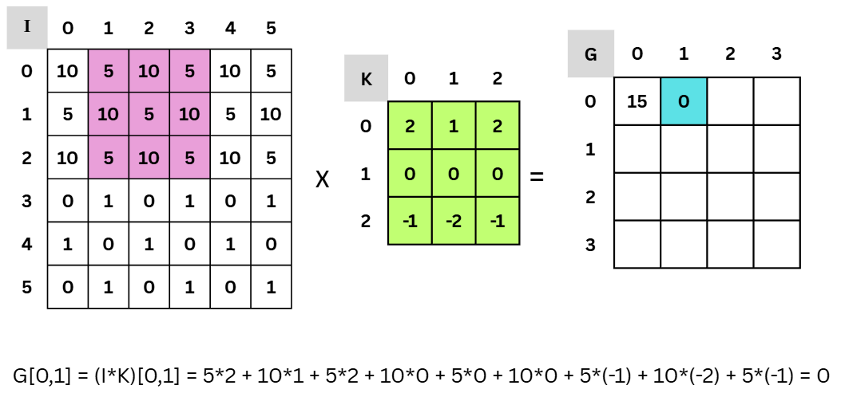

*Figure 2.1.1.1.* Convolutional Algorithm Example

#### ReLU Activation Function

The Rectified Linear Unit (ReLU) is a crucial activation function in CNNs. It is utilized to add non-linearity into the model and described as a function that enables the network to recognize intricate patterns by setting all negative values in the feature map to zero. ReLU activation reduces the vanishing gradient issue and speeds up convergence. The ReLU function is defined and plotted as Figure 2.1.1.2 below:

$$ReLU\left(x\right)=max⁡(0, x)$$

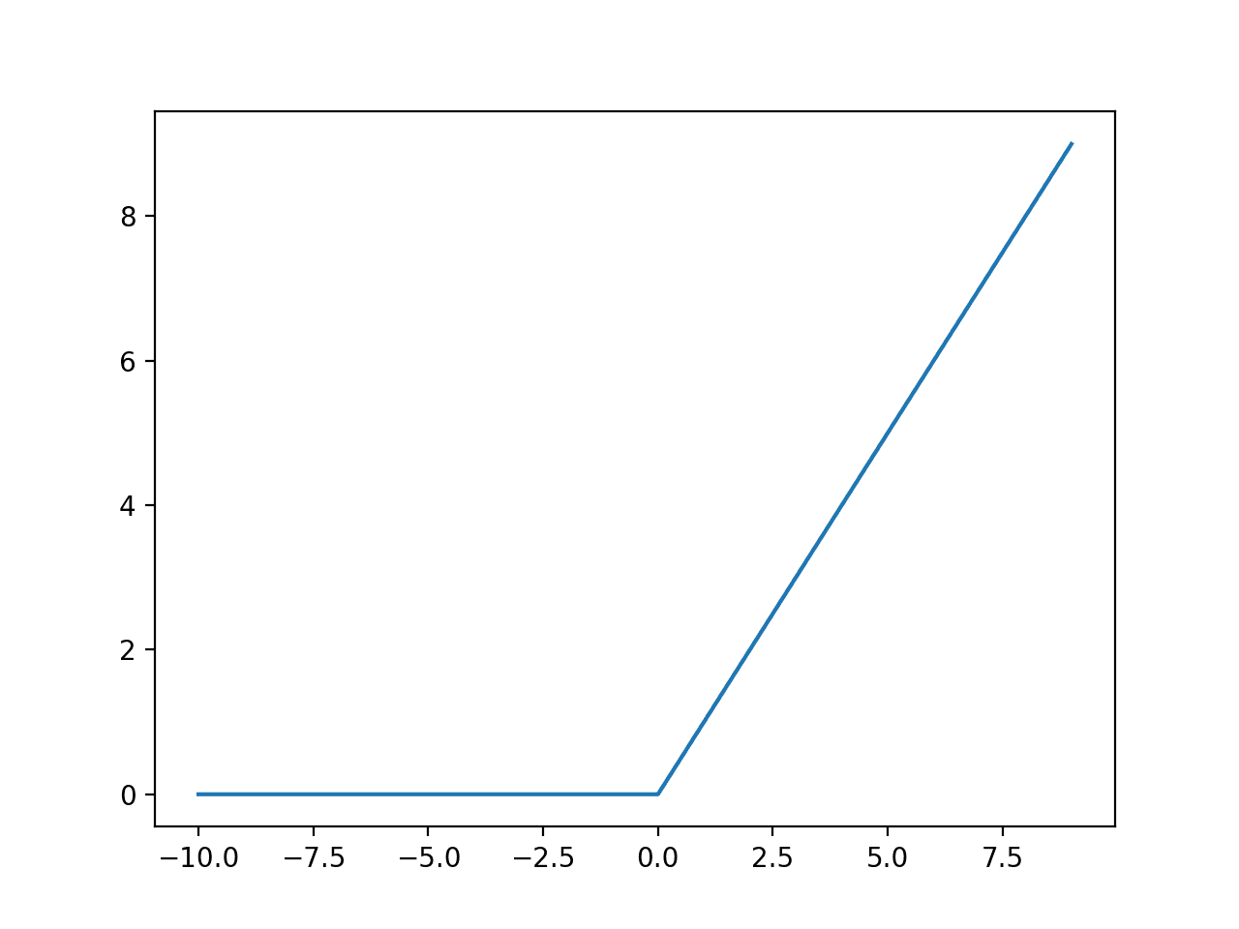

*Figure* *2.1.1.2*. ReLU Activation Function Plot Graph

#### Pooling

A downsampling technique called pooling lowers the complexity of feature maps while keeping significant features. Max-pooling is one of the most popular types of pooling techniques, it chooses the highest value from a feature map region. This process facilitates the achievement of spatial invariance while lowering computing cost. A 2x2 max-pooling operation on a feature map will choose the highest value from every 2x2 region, as we can see in Figure 2.1.1.3 for each colored 2x2 region.

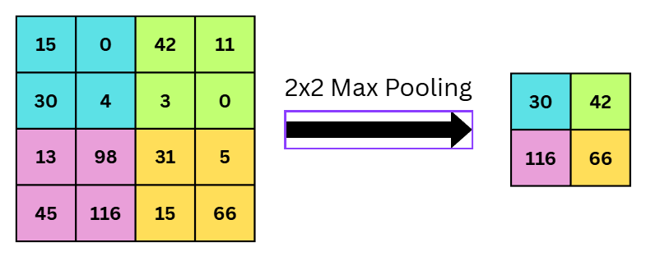

*Figure 2.1.1.3.* Max-pooling Example

#### Fully Connected Layer

The CNN architecture uses fully connected (FC) layers at the end to carry out categorization. Every neuron in an FC layer is linked to every other neuron in the layer above it. A bias term is then added after the outputs from the earlier layers have been flattened into a single vector and multiplied by a weight matrix. Mathematically, this process is defined as the function below, where x is the input vector, W is the weight matrix, b is the bias vector and y are the output vector. Figure 2.1.1.4 demonstrates the functionality of the layer is also shown.

$$y=Wx+b$$

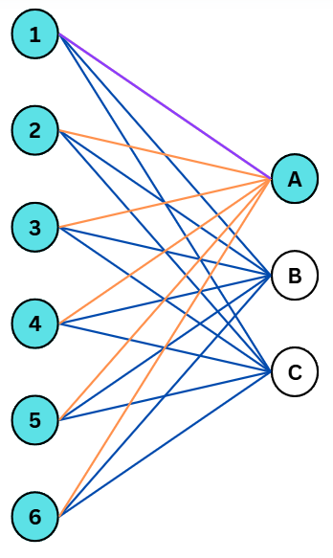

*Figure 2.1.1.4.* Fully Connected Layer Illustration

### Logical Structure

Figure 2.1.2 below displays the overall network's structure. The input image will pass through two main layer levels, each of which consists of a Convolution with different number and type of kernels, and a Max-ReLU activation layer. After that, the entire network's output will pass through the MLP layer to produce a network interpretation. Using two 5x5 kernels, the first convolution layer will convert a given 28x28 image into two channels of a 24x24 image. It will then become two channels of a 12x12 image after passing through a max-pooling layer and a ReLU activation layer. The second convolution layer will then use three 2x3x3 kernels to transfer it to three channels of a 10x10 image. After that, it will pass through another max-pooling and ReLU activation layer, resulting in a 5x5 image with three channels. After that, it will be flattened into a 1x75 array. A fully connected layer at the end will transform the array into a 1x10 array, and the system's output will be the index pointing to the highest probability of the digit in the array.

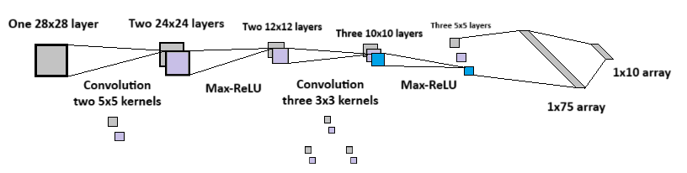

*Figure 2.1.2.* Logical Structure of CNN

### **CNN Architecture**

#### MNIST Dataset

Large collections of handwritten numbers from the Modified National Institute of Standards and Technology (MNIST) database are frequently used to train different image processing programs. Additionally, the database is frequently utilized for machine learning testing and training. By modifying the samples from the original NIST datasets, it was produced. The researchers believed that NIST was not a good fit for machine learning experiments since its training dataset was derived from American Census Bureau employees, whereas its testing dataset was derived from American high school students. In addition, the NIST black and white photos were anti-aliased and normalized into a 28x28 pixel bounding box, which added grayscale levels. There are 10,000 test images and 60,000 training images in the MNIST database as shown in Figure 2.1.3.1. While NIST's training dataset provided half of the training set and half of the test set, and NIST's testing dataset provided the other half of the training set and the other half of the test set. A list of some of the techniques tested on the database is maintained by its original designers. They obtained an error rate of 0.8% in their original study by using a support-vector machine. In 2017, EMNIST - an expanded dataset similar to MNIST - was released. It comprises 40,000 testing photos and 240,000 training images of handwritten letters and numbers.

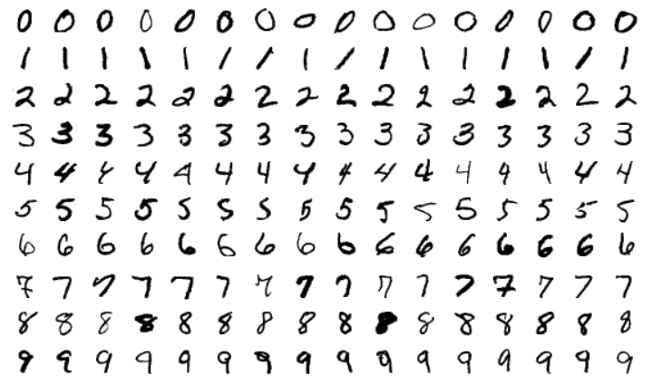

*Figure 2.1.3.1.* MNIST Example Dataset

#### Simple CNN Model

Since Pytorch is one of the most easy-to-use libraries, we used it to create the basic CNN based on the logical structure above. This step can also be completed using other libraries such as Keras or Tensorflow. The basic CNN with two main convolution layers and one fully connected layer after experimenting with the parameters is indicated in Figure 2.1.3.2. Since the MNIST datasets are grayscale images, the first convolution layer enlarges a single channel input into two channels of output. The size of the kernel is 5x5, its stride is 1, and its padding is 0. The input and output of the second convolution layer are two and three channels, respectively. Each convolution layer is followed by a max pooling layer and a ReLU layer. In order to make the data flow of FPGA easier to handle, these numbers are chosen to guarantee that no padding is required at any layer. The model can attain 96% or higher accuracy on the MNIST validation set after being trained for 10 epochs with a batch size of 600. With the intention of facilitating hardware validation and debugging, test hooks are also implemented to provide logging outputs at every layer.

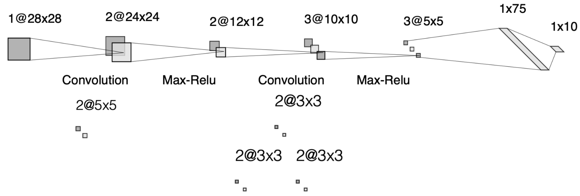

*Figure 2.1.3.2.* Simple CNN Architecture

## Related works

### Image classification of MNIST using VGG16

The Visual Geometry Group (VGG) at the University of Oxford proposed the VGG-16 model CNN architecture, as shown in Figure 2.2.1. With 16 layers - 13 convolutional layers and 3 fully connected layers - it is distinguished by its depth. VGG-16 is well known for its ease of use and efficiency, as well as its superior performance on a range of computer vision tasks, such as object recognition and image categorization. The architecture of the model consists of a stack of convolutional layers gradually increasing in depth, followed by max-pooling layers. The model can learn complex hierarchical representations of visual characteristics thanks to this approach, producing predictions that are reliable and accurate.

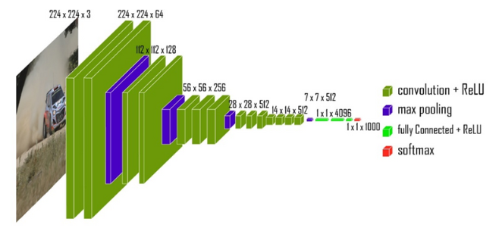

*Figure 2.2.1.* VGG-16 Architecture

# CHAPTER III METHODOLOGY

In this thesis project, Convolutional Neural Networks (CNNs) is improved to accelerate handwritten digit recognition by completing the architecture on FPGA. First, by thoroughly testing each network layer, Verilog is used as HDL and the verification of each module is done by using ModelSim. After ensuring the time is accurate, the Python scripts are utilized to verify its functionality. A data flow mechanism is constructed from the input image through each of these layers to the output, integrating them into a coherent system. Furthermore, PyTorch is used to train a simple CNN model using the MNIST dataset and extracted the weights and bias for the fully connected and convolutional layers. The hardware system was primed for classification tasks by loading these weights into it. By thoroughly evaluating the accuracy of the system using actual handwritten samples as well as digits from the MNIST dataset, a great increase in performance and efficiency by shifting calculation from software to specialized hardware, allowing quicker and more precise digit recognition.

## Training CNN Model

To evaluate which CNN model is the most appropriate based on timing and simplicity criteria, three different CNN models are trained and compared. By using Pytorch, a simple CNN model is designed individually according to the logical structure; one pretrained CNN models are used for the digit recognition tasks with Keras and Tensorflow. Besides comparing the training time and the simplicity of the architecture, the loss and accuracy probabilities are also the standard to decide which model is used for this project.

### Simple CNN Model

To extract the weights and bias from the CNN model used for the project, the Pytorch library is first imported. Next, the MNIST dataset is loaded to get the train and test database. Then, the neural network is designed based on the logical structure of the project including two main convolutional layers and one fully connected layer. The parameters of the neural network are optimized using Adam optimizer algorithm. After that, the data is trained through 10 epochs, the batch size is 600, each epoch contains 100 steps, the accuracy and loss probabilities are also observed to check the integrity of the training section. The model is tested through an example in the MNIST database and saved to obtain the weights and bias of each layer to load into and implemented on FPGA. The arithmetic process, the workflow, the architecture of the network is shown in Figure 3.1.1.1, 3.1.1.2 and 3.1.1.3, respectively.

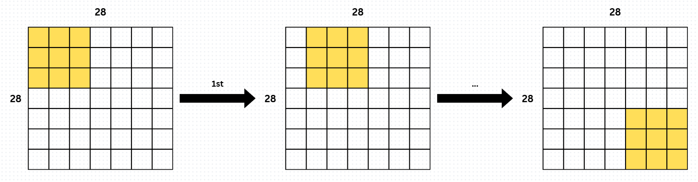

*Figure 3.1.1.1.* Arithmetic Process of Convolutional Layer

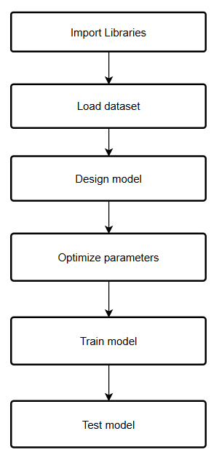

*Figure 3.1.1.2.* Simple CNN Model DesignWorkflow

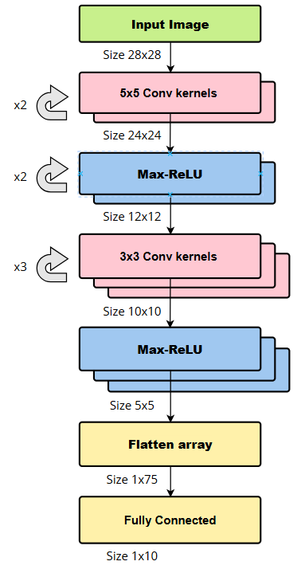

*Figure 3.1.1.3.* Simple CNN Model Architecture

### VGG-16 Model

To understand the reason using the simple CNN model instead of different pretrained models, the VGG-16 model is chosen to compare the time consumption for training, the accuracy and the ability to design and implement the compatible model on the FPGA. Similar to the previous model, the libraries needed are first imported, however, the Tensorflow and Keras libraries are used due to the convenience. Next, the MNIST database is loaded to obtain the train and test dataset. However, the data loaded needs to be processed before training the model by reshaping into tensor format to match the requirement of VGG-16 model. Instead of building the neural network, the pretrained model is loaded directly from the library and then customized internal layers for better result in training. The customized model is compiled and optimized using Adam optimizer algorithm. After that, the model is fitted with 20 epochs, the batch size is 128, each epoch contains 375 steps. The next step is evaluating the model through 10000 test images. Although the digit recognition task from several examples gives higher accuracy than the simple one, the training speed and the complexity of the model with many layers are not suitable for memory inside FPGA. Figure 3.1.2.1 and 3.1.2.2 demonstrated the execution steps and architecture of the VGG-16 model.

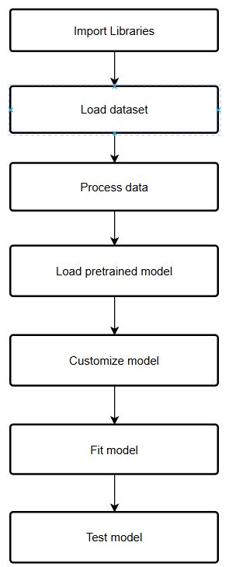

*Figure 3.1.2.1.* VGG-16 Model DesignWorkflow

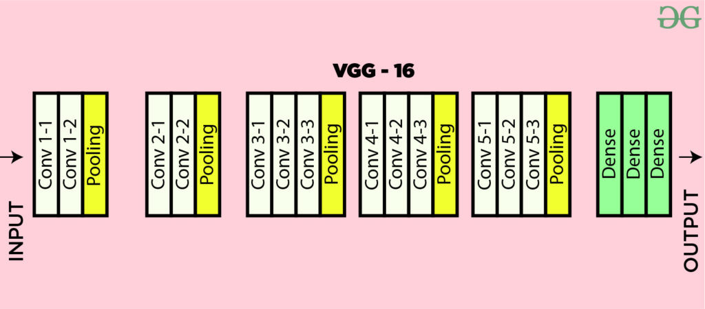

*Figure 3.1.2.2.* VGG-16 Model Architecture

## Image Conversion

The raw image is generated by using Paint app with white color brush on black background on Windows 11. For simplicity, the image is converted into greyscale array format, the element inside the array is then flattenned to 1D and normalized to -8192…8192 range. After that, using the Q2.13 notation, which is demonstrated in Figure 3.2.1, to convert to signed float fixed point format with 7 digit before and 8 digit after the decimal point. Finally, the data is saved under .dat format.

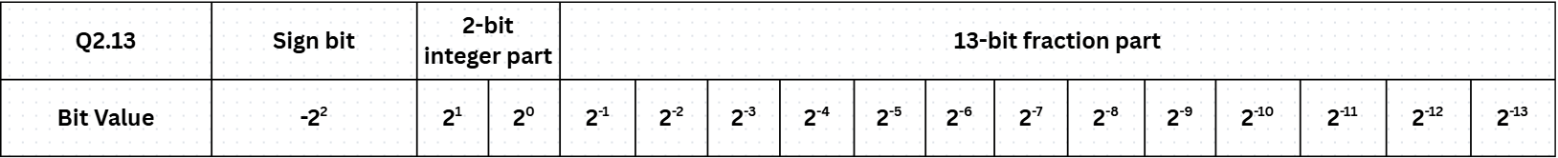

*Figure 3.2.1.* Q2.13 bits declaration

## MIF File Generation

To load data of weights or bias into M4K RAM, which is the memory block inside the DE2 Cyclone II Board, the .dat file is not compatible, so it needs to be in the MIF format, which is a file format conveying binary in ASCII text form, to be compatible with the DE2 board. Each line generated in the .mif file represents a 16-bit signed float fixed point under hexadecimal radix, which is four hexadecimal numbers, for example 00FF. Two python scripts converting the images, weights and bias of each layer from .txt file exported from the model trained before into .mif file is also designed in each kernel from float format into a mif file holding 16-bit signed fixed-point hexadecimal representing the data which has 1-bit signed, 2-bit digit and 13-bit decimal.

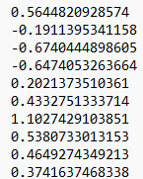 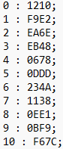

*Figure 3.3.1.* Q2.13 Conversion from Float to Hexadecimal

## Storage Unit

### Load weights into code using $readmemh

Using the $readmemh function, the weights and biases learned from the CNN model in Python are exported into hexadecimal (.hex) files and subsequently imported into the Verilog design. This method eliminates the requirement to hardcode precomputed parameters into the source code by enabling direct access to them by the hardware implementation. At simulation time, internal memory arrays are read for the fixed-point representations of the model parameters included in each .hex file. The CNN on FPGA can replicate the same behavior as the software-trained model by storing weights and biases in this manner, which allows the Verilog modules to execute inference using actual model data. Scalability, modularity, and effective incorporation of machine learning models into digital hardware are guaranteed by this approach. Figure 3.4.1.1 below shows the syntax of using $readmemh for simulation in ModelSim.



*Figure 3.4.1.1.* MegaWizard Plug-In Manager Page 1

### Load weights into FPGA board using ROM 1-port

For an MNIST digit-recognition CNN that never changes its learned parameters, the cleanest way to store the convolution weights and biases in an Intel FPGA is to create a single-port ROM with the Quartus *MegaWizard Plug-In Manager*. Export the trained weights as a 16-bit .mif or .hex file, feed that file to the wizard, and select “1-port ROM” so each clock returns one weight word. Quartus maps the ROM into on-chip M4K/M10K block RAM, which powers-up already pre-loaded. Figure 3.4.2.1 indicates the first page of creating a single-port ROM using MegaWizard Plug-In Manager in Quartus II 9.0.



*Figure 3.4.2.1.* MegaWizard Plug-In Manager Page 1

Figure 3.4.2.2 shows MegaWizard Plug-In Manager – Page 2, where the memory block that will hold the CNN’s immutable parameters is defined. In the left-hand tree the designer selects Memory Compiler → ROM: 1-PORT, the most compact choice when weights and biases are fixed after training, because the logic only needs to *read* one 16-bit word per clock. On the right, Verilog HDL is chosen as the output language so the generated IP can be instantiated directly in the project’s Verilog source. Finally, the output-file name is set to match the associated weight or bias .mif file (e.g., bias_conv1.v for bias_conv1.mif), keeping each ROM and its initialization data paired and easy to track throughout the build flow.



*Figure 3.4.2.2.* MegaWizard Plug-In Manager Page 2

As illustrated in Figure 3.4.2.3, the parameter‐setting page of the MegaWizard is configured for the Cyclone II device family, thereby ensuring that the generated memory primitive is compatible with the target FPGA. The output width of the ‘q’ port is fixed at 16 bits to match the numerical precision of the stored bias values, while the depth is set to two words because the convolution layer contains exactly two bias coefficients. To guarantee that the memory is implemented inside an on-chip block RAM rather than being inferred from logic cells, the option “M4K” is explicitly selected; Quartus therefore reserves a single M4K block, as indicated in the resource-usage pane. Finally, the “single clock” mode is chosen, so both address and data are registered on the same system clock edge, simplifying timing closure and avoiding the overhead of separate read and write clocks.

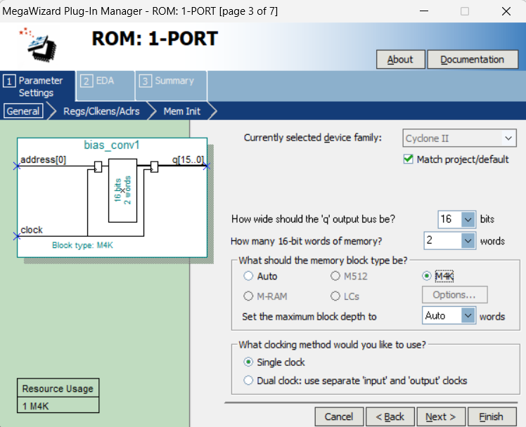

*Figure 3.4.2.3.* MegaWizard Plug-In Manager Page 3

Figure 3.4.2.4 presents the register-selection page, where both the address input and the q output ports are flagged for registration. Enabling the *q output port* checkbox inserts a flip-flop on the data bus inside the M4K block, so every sixteen-bit bias value appears one clock cycle after the address is applied and is fully synchronous with the system reference clock. This extra register stage eliminates combinational hold-time paths from the ROM to the consuming logic, eases timing closure at higher frequencies, and guarantees that the bias word is stable for the entire clock period in which it is used.

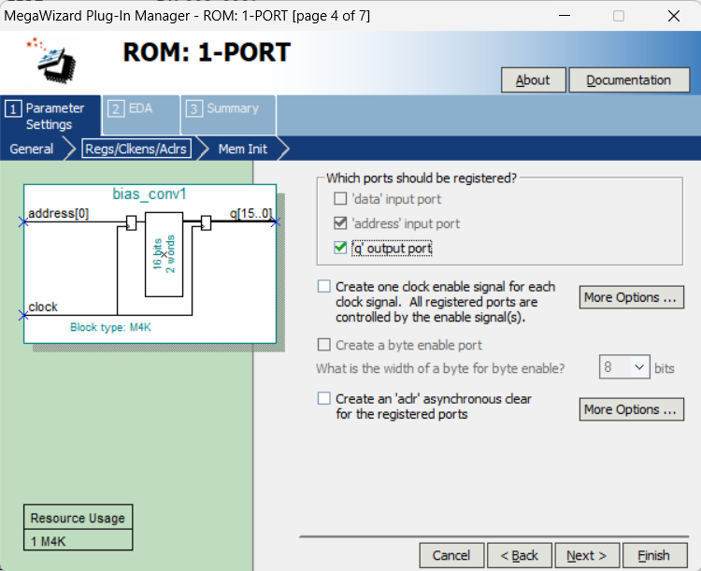

*Figure 3.4.2.4.* MegaWizard Plug-In Manager Page 4

Figure 3.4.2.5 shows the memory-initialisation page, where the ROM is pre-loaded with the trained parameters. The option “Yes, use this file for the memory content data” is selected and the path to a .mif (or .hex) file is provided; the file must follow Intel/Quartus syntax—one word per line, depth and width headers correctly defined—so the assembler can parse it without warnings. At configuration time Quartus copies these values into the M4K block, meaning the bias or weight data are available immediately after power-up with no run-time transfers. If the designer prefers to load the coefficients dynamically, this field can be left blank and dual-port RAM chosen instead, allowing the system to write the weights through a second port while the FPGA is running.

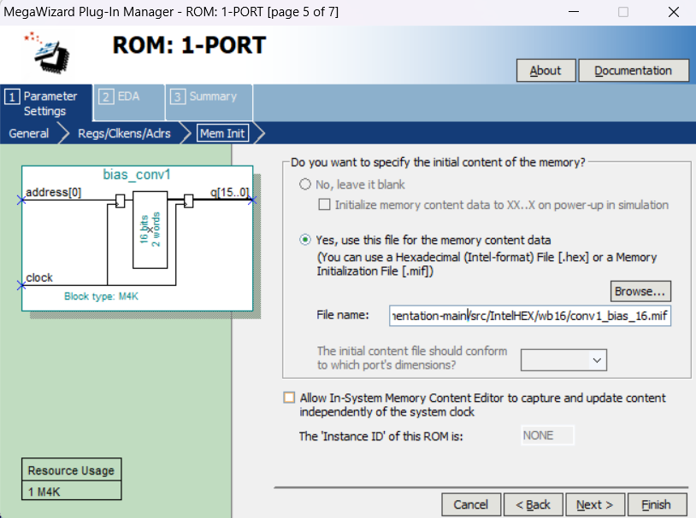

*Figure 3.4.2.5.* MegaWizard Plug-In Manager Page 5

## CNN Model Layers

As listed above, there are two main convolutional layers and one fully connected layer. Inside the main convolutional layer, it contains one convolution and one Max-ReLU activate function. Some algorithms are used for better compiling such as sliding window, fixed point multipliers. Only fully connected layer module and top module requires FSM design.

### First Convolutional Layer

*Table 3.5.1.1.* First Convolutional Layer State Machine

|  |  |  |
| --- | --- | --- |
| **State** | **Name** | **Description** |
| 0 | S_IDLE | Waiting for the start signal and reseting the default value. |
| 1 | S_LOAD | Loading all the image input and fixed weights and biases. |
| 2 | S_COMPUTE | Executing the algorithm of fully connected layer, using matrix dot and sliding window. |
| 3 | S_DONE | Waiting for start signal to reload the algorithm. |

*Table 3.5*.*1.2*. First Convolutional Module Port Declaration

|  |  |  |
| --- | --- | --- |
| **Name** | **Port type** | **Bit width** |
| IN_CHANNELS | Parameter | 1 |
| OUT_CHANNELS | Parameter | 2 |
| IN_IMG_SIZE | Parameter | 28 |
| OUT_IMG_SIZE | Parameter | 24 |
| KERNEL_SIZE | Parameter | 5 |
| DATA_WIDTH | Parameter | 16 |
| ACC_WIDTH | Parameter | 32 |
| clk | Input Wire | 1 |
| reset_n | Input Wire | 1 |
| start_conv1 | Input Wire | 1 |
| clock_enb | Input Wire | 1 |
| data_valid | Input Wire | 1 |
| image_in | Input Wire Signed | 16 |
| result_valid | Output Reg | 1 |
| map_out | Output Reg Signed | 16 |
| finish_conv1 | Output Reg | 1 |

### First Max Pooling Layer

*Table 3.5*.*2*. First MaxPool2x2ReLU Module Port Declaration

|  |  |  |
| --- | --- | --- |
| **Name** | **Port type** | **Bit width** |
| IMG_SIZE | Parameter | 24 |
| CHANNELS | Parameter | 2 |
| DATA_WIDTH | Parameter | 16 |
| clk | Input Wire | 1 |
| reset_n | Input Wire | 1 |
| start_max1 | Input Wire | 1 |
| clock_enb | Input Wire | 1 |
| data_valid | Input Wire | 1 |
| data_in | Input Wire Signed | 16 |
| result_valid | Output Reg | 1 |
| data_out | Output Reg Signed | 16 |
| finish_max1 | Output Reg | 1 |

### Second Convolutional Layer

*Table 3.5.3.1.* First Convolutional Layer State Machine

|  |  |  |
| --- | --- | --- |
| **State** | **Name** | **Description** |
| 0 | S_IDLE | Waiting for the start signal and reseting the default value. |
| 1 | S_LOAD | Loading all the image input and fixed weights and biases. |
| 2 | S_COMPUTE | Executing the algorithm of fully connected layer, using matrix dot and sliding window. |
| 3 | S_DONE | Waiting for start signal to reload the algorithm. |

*Table 3.5*.*3.2*. Second MaxPool2x2ReLU Module Port Declaration

|  |  |  |
| --- | --- | --- |
| **Name** | **Port type** | **Bit width** |
| IN_CHANNELS | Parameter | 2 |
| OUT_CHANNELS | Parameter | 3 |
| IN_IMG_SIZE | Parameter | 12 |
| OUT_IMG_SIZE | Parameter | 10 |
| KERNEL_SIZE | Parameter | 3 |
| DATA_WIDTH | Parameter | 16 |
| ACC_WIDTH | Parameter | 32 |
| clk | Input Wire | 1 |
| reset_n | Input Wire | 1 |
| start_conv2 | Input Wire | 1 |
| clock_enb | Input Wire | 1 |
| data_valid | Input Wire | 1 |
| image_in | Input Wire Signed | 16 |
| result_valid | Output Reg | 1 |
| map_out | Output Reg Signed | 16 |
| finish_conv2 | Output Reg | 1 |

### Second Max Pooling Layer

*Table 3.5*.*4*. Second MaxPool2x2ReLU Module Port Declaration

|  |  |  |
| --- | --- | --- |
| **Name** | **Port type** | **Bit width** |
| IMG_SIZE | Parameter | 10 |
| CHANNELS | Parameter | 3 |
| DATA_WIDTH | Parameter | 16 |
| clk | Input Wire | 1 |
| reset_n | Input Wire | 1 |
| start_max2 | Input Wire | 1 |
| clock_enb | Input Wire | 1 |
| data_valid | Input Wire | 1 |
| data_in | Input Wire Signed | 16 |
| result_valid | Output Reg | 1 |
| data_out | Output Reg Signed | 16 |
| finish_max2 | Output Reg | 1 |

### Fully Connected Layer

*Table 3.5.5.1.* Fully Connected Layer State Machine

|  |  |  |
| --- | --- | --- |
| **State** | **Name** | **Description** |
| 0 | S_IDLE | Waiting for the start signal and reseting the default value. |
| 1 | S_LOAD | Loading all the data input from previous second max pooling layer. |
| 2 | S_COMPUTE | Executing the algorithm of fully connected layer, using matrix dot and sliding window. |

*Table 3.5.5.2.* Fully Connected Layer Module Port Declaration

|  |  |  |
| --- | --- | --- |
| **Name** | **Port type** | **Bit width** |
| IN _SIZE | Parameter | 75 |
| OUT _SIZE | Parameter | 10 |
| DATA_WIDTH | Parameter | 16 |
| ACC_WIDTH | Parameter | 32 |
| clk | Input Wire | 1 |
| reset_n | Input Wire | 1 |
| start_fc | Input Wire | 1 |
| clock_enb | Input Wire | 1 |
| data_valid | Input Wire | 1 |
| map_in | Input Wire Signed | 16 |
| result_valid | Output Reg | 1 |
| map | Output Reg Signed | 16 |
| finish_fc | Output Reg | 1 |

### ArgMax Layer

*Table 3.5.4.1.* ArgMax Layer State Machine

|  |  |  |
| --- | --- | --- |
| **State** | **Name** | **Description** |
| 0 | S_IDLE | Waiting for the start signal to reset the default value and load data into array. |
| 1 | S_RUN | Executing the algorithm of ArgMax, using comparison to get the largest value. |
| 2 | S_DONE | Waiting for start signal to reload the algorithm. |

*Table 3.5.4.2*. ArgMax Layer Module Port Declaration

|  |  |  |
| --- | --- | --- |
| **Name** | **Port type** | **Bit width** |
| IN_SIZE | Parameter | 10 |
| DATA_WIDTH | Parameter | 16 |
| clk | Input Wire | 1 |
| reset_n | Input Wire | 1 |
| start_argmax | Input Wire | 1 |
| clock_enb | Input Wire | 1 |
| data_valid | Input Wire | 1 |
| class_in | Input Wire Signed | 16 |
| index_out | Output Reg | 4 |
| finish_argmax | Output Reg | 1 |

### Top Convolutional Neural Network

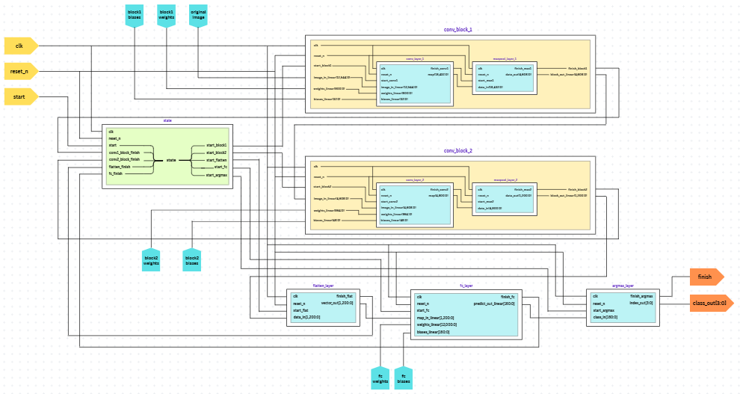

*Figure 3.5.7.1.* RTL Diagram of Convolutional Top Module

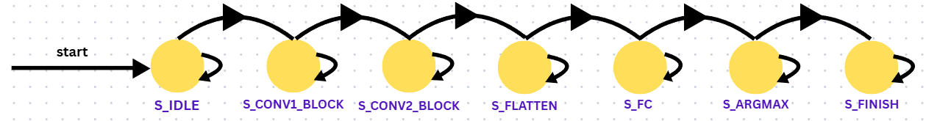

*Figure 3.5.7.2.* State Machine of Convolutional Top Module

*Table 3.5.7.* Top Convolutional Neural Network Module Port Declaration

|  |  |  |
| --- | --- | --- |
| **Name** | **Port type** | **Bit width** |
| IMG_CHANNELS | Parameter | 1 |
| IMG_WIDTH | Parameter | 28 |
| IMG_HEIGHT | Parameter | 28 |
| DATA_ WIDTH | Parameter | 16 |
| CONV1_OUT_CHANNELS | Parameter | 2 |
| CONV2_OUT_CHANNELS | Parameter | 3 |
| CONV1_ KERNEL | Parameter | 5 |
| CONV2_ KERNEL | Parameter | 3 |
| clk | Input Wire | 1 |
| reset_n | Input Wire | 1 |
| start | Input Wire | 1 |
| data_valid | Input Wire | 1 |
| class_out | Output Reg | [3:0] |
| finish_out | Output Reg | 1 |

# CHAPTER IV RESULTS

This chapter contains the results of training two CNN models on Colab using Torch, Keras and Tensorflow. The weights and bias of the chosen CNN is clearly shown and exported to .txt file for hexadecimal conversion. The image processing step to transform the file into Intel HEX file to be compatible with the FPGA is also explained. Each layer in CNN is first designed and synthesized using Quartus 9.0, then tested and verified by indiviual testbench using ModelSim-Altera 4.4a. The waveforms are displayed to observe the behavior and evaluate the precision.

## Training CNN Model

### Simple CNN Model

Starting by configuring the type of device in Colab, the CPU is used because of the basic architecture of the model, it does not require a high-accelerate device to compile and train.

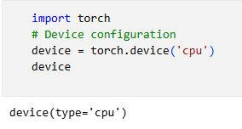

*Figure 4.1.1.1.* Device Configuration

After that, the MNIST dataset is imported from “torchvision” library, the ‘train_data’ is the only data being trained; therefore, the train boolean value of the ‘test_data’ is set to ‘False’. Both datasets are transformed into Pytorch tensor preparing for the consumption by Pytorch models through the ‘ToTensor()’ function. It also handles the scaling of the image pixel value to the range [0.0, 1.0]. For many deep learning models to provide consistent training and improved performance, this normalization is essential.

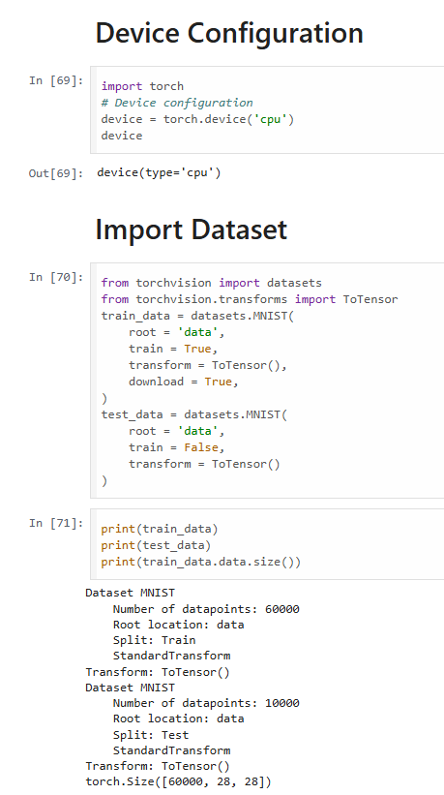

*Figure 4.1.1.2.* Dataset Preparation

After loading the MNIST dataset, the batch size is set to 128 for both types of data and they are suffled for reputated verification.

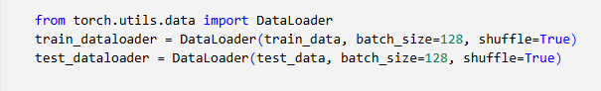

*Figure 4.1.1.3.* Load Data Preparation

The logical structure is implemented using the ‘nn’ library, which is the neural network. The ‘Sequential’ function is used to design two main convolutional layers, each containing a convolution, a ReLU and a Max Pool activate function. The CNN module is printed to check the setting of each layer.

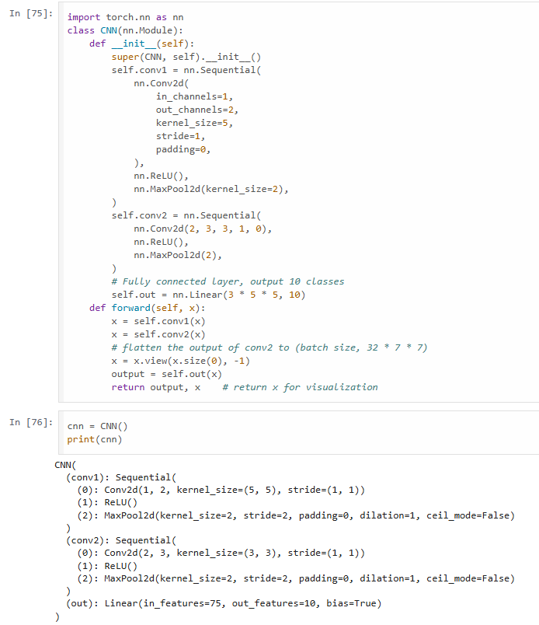

*Figure 4.1.1.4.* Logical Structure Design

Next, optimizing the data is an important part of maximizing the ultility of the data for training. In this section, Adam optimizer with learning rate of 0.01 is chosen because of the significant outperformance in terms of both training and convergence accuracy compared with Stochastic Gradient Descent (SGD) optimizer.

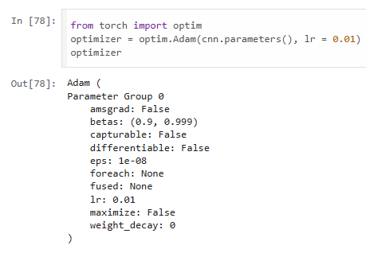

*Figure 4.1.1.5.* Data Optimization

The model is trained through 10 epochs; each epoch has 469 steps. The loss probability is printed to observe the loss in each epoch. The total training time is 133.191s. Each step inside is commented and explained in the for loop.

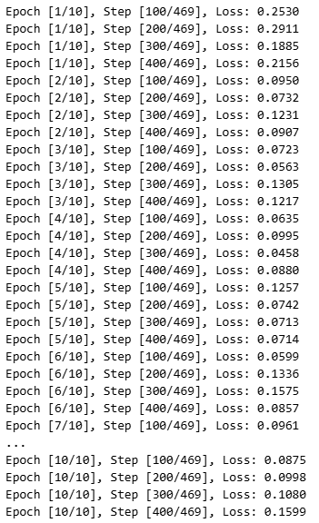

*Figure 4.1.1.4.* Model Training

After training, the model is tested and verified by printing out the accuracy probability using the test data. The accuracy probability results in 0.95 or higher.

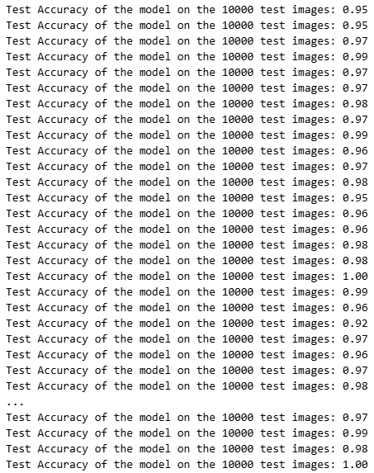

*Figure 4.1.1.7.* Accuracy Testing

The model’s state_dict, which lists the shapes of all learned parameters (weights and biases) in CNN. Each line corresponds to a specific layer. The first layer, conv1.0.weight, has shape [2, 1, 5, 5], meaning it has 2 filters, each with 1 input channel and a kernel size of 5×5. Its bias term conv1.0.bias has shape [2], assigning one bias per filter. The second convolutional layer, conv2.0.weight, has shape [3, 2, 3, 3], representing 3 filters operating on 2 input channels with 3×3 kernels. The corresponding biases conv2.0.bias have 3 values, one per filter. Finally, the fully connected output layer out.weight connects 75 input features to 10 output classes (shape [10, 75]), with out.bias contributing a separate bias value for each of the 10 output classes. These tensor shapes confirm the CNN structure and determine how the parameters are loaded and mapped in the FPGA design and are indicated in Figure 4.1.1.8 below.

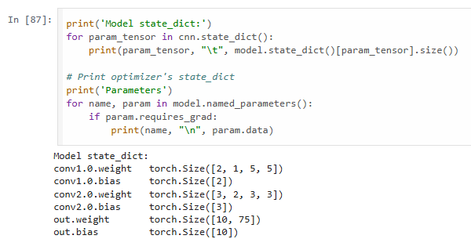

*Figure 4.1.1.8.* Model State Result

Figure 4.1.1.9 displays the actual trained parameters of the first convolutional layer (conv1.0) after training. The conv1.0.weight tensor has a shape of [2, 1, 5, 5], meaning there are 2 filters, each applied to 1 input channel with a kernel size of 5×5. The figure shows the values of these filters as floating-point numbers, representing how each filter responds to specific spatial patterns in the input image. These weights are used during convolution to extract low-level features such as edges or textures. Below the weights, the conv1.0.bias tensor contains two values, one bias per filter. These biases are added after the convolution operation to help the network better fit the data. These parameters will later be quantified and converted into fixed-point hexadecimal values to be loaded into the FPGA for hardware inference.

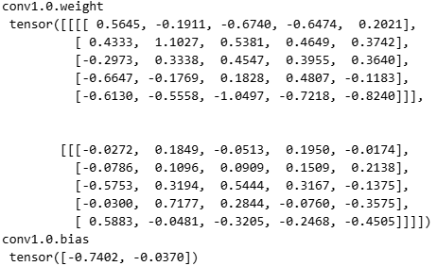

*Figure 4.1.1.9.* First Convolutional Layer Weights and Bias

Figure 4.1.1.10 presents the trained weights and bias values for the second convolutional layer conv2.0 in the CNN model. The conv2.0.weight tensor has the shape [3, 2, 3, 3], meaning there are 3 output filters, each operating on 2 input channels with a kernel size of 3×3. This layer takes as input the output feature maps from the first convolutional layer and extracts higher-level features. Each filter is represented by two 3×3 matrices (for the 2 input channels), and their values define how the filter responds to spatial patterns across the channels. Below the weights, the conv2.0.bias tensor contains 3 values, one for each filter, which are added after the convolution operation to adjust the activation levels. These floating-point parameters are essential for maintaining the learned behavior of the CNN when deployed in hardware. Before implementation on FPGA, they are converted to fixed-point format and stored in memory (e.g., HEX or binary format) to be loaded using $readmemh or via UART communication.

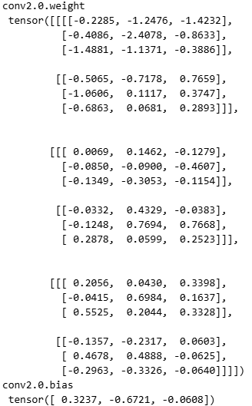

*Figure 4.1.1.10.* Second Convolutional Layer Weights and Bias

The first weight channel of the output fully connected (dense) layer out.weight in the CNN model is declared in Figure 4.1.1.11. This layer connects the flattened feature vector from the previous layer (of size 75) to the 10 output classes (digits 0–9), and the weight tensor has the shape [10, 75]. Each row represents the weights associated with one output neuron, and each column corresponds to a feature from the flatten layer. The values are represented in scientific notation, indicating precise floating-point numbers learned during training. These weights determine how strongly each feature contributes to a specific class prediction. Along with the associated out.bias in Figure 4.1.1.12, these parameters complete the final computation stage of the CNN, producing the class logits. For FPGA deployment, the weights are quantized to fixed-point representation and stored in memory. They are then loaded into the design using $readmemh or through UART to perform real-time digit classification.

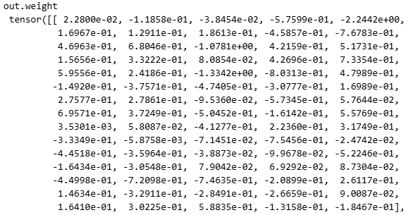

*Figure 4.1.1.11.* Output Layer Weights



*Figure 4.1.1.12.* Output Layer Biases

### VGG-16 model

The architecture of the custom VGG-16 model is presented in Figure 4.1.2.1, highlighting its layer-wise configuration, output dimensions, and parameter counts. VGG-16 is a deep convolutional neural network composed of 13 convolutional layers, 5 max-pooling layers, and 3 fully connected (dense) layers. The model accepts input images of shape (224, 224, 3) and progressively reduces spatial dimensions through pooling operations while increasing the number of feature maps, reaching 512 channels by the fifth convolutional block. The final feature maps are flattened into a 25,088-dimensional vector before being passed to two dense layers of size 4,096 and a final classification layer of 1,000 outputs, suitable for ImageNet classification. The total number of trainable parameters is approximately 138 million, making VGG-16 a computationally intensive model, particularly in the fully connected layers. Its simplicity in design and high performance have made it a popular choice in transfer learning and computer vision applications.

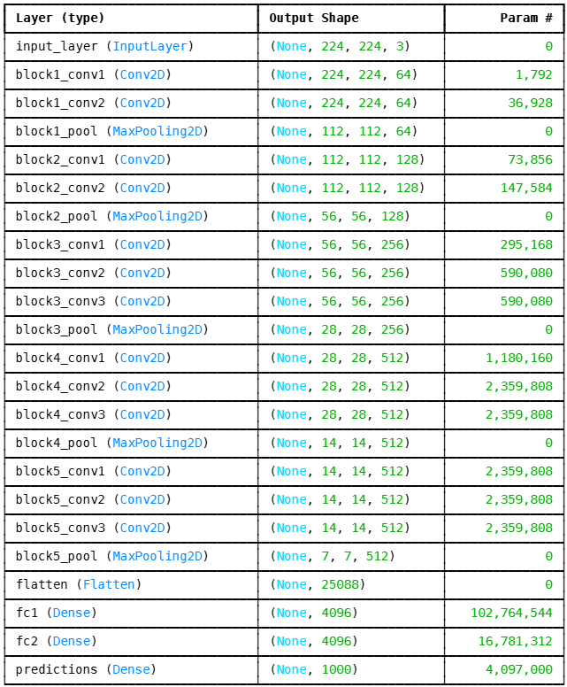

*Figure 4.1.2.1.* VGG-16 Model

The initial customization of the VGG16 model is illustrated in Figure 4.1.2.2 and Figure 4.1.2.3. In this step, the model is modified to better suit the target task by first defining a custom input layer and then removing the original top (fully connected) layers. This approach is commonly used in transfer learning, where the convolutional base of a pre-trained model is retained to leverage its feature extraction capabilities, while the classification head is replaced with a new structure tailored to a specific dataset. The output also shows the downloading process of the pre-trained weights from the TensorFlow repository, confirming that the model is being loaded without the top layers. This allows the user to build and train a new classifier on top of the rich feature representations learned by VGG16 from large-scale datasets like ImageNet.

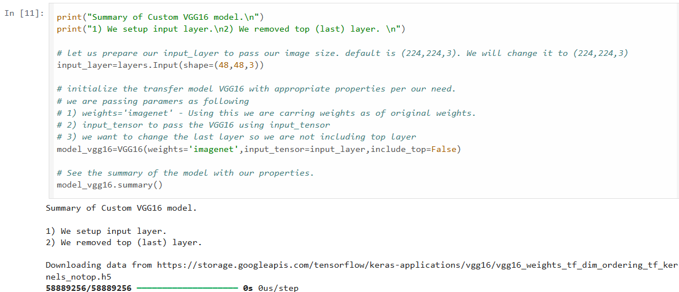

*Figure 4.1.2.2.* Model First Customization

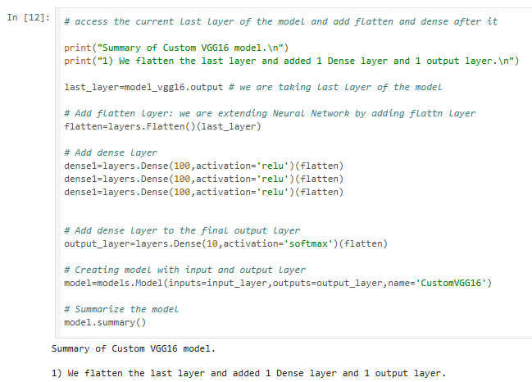

*Figure 4.1.2.3.* Model Second Customization

Figure 4.1.2.4 shows the architecture of the Custom VGG16 model, designed for image classification with input dimensions of 48×48×3. The model follows a simplified VGG16 structure, consisting of five convolutional blocks with 3×3 filters and increasing depth from 64 to 512 filters, each followed by max pooling layers that reduce spatial dimensions. After the final pooling layer, the output is flattened and passed to a dense layer with 10 output units for classification. The model contains approximately 14.7 million parameters, of which only 5,130 are trainable, indicating the use of a pre-trained convolutional base with only the final layer fine-tuned. This approach leverages transfer learning for improved efficiency and performance on smaller datasets.

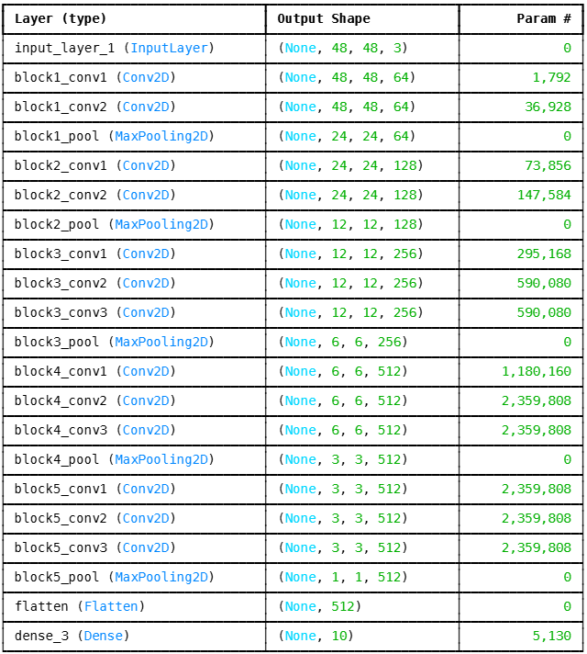

*Figure 4.1.2.4.* Custom VGG-16 Model

Figures 4.1.2.5 and 4.1.2.6 indicate the training progress and result of the Custom VGG16 model, respectively. Figure 4.1.2.5 displays training and validation accuracy and loss values recorded across 20 epochs. The model exhibits rapid convergence, achieving over 90% training accuracy by the third epoch and consistently maintaining above 91% validation accuracy in subsequent epochs. The validation loss also decreases steadily, indicating effective learning without significant overfitting. By the final epoch, the model achieves a training accuracy of 93.19% and a validation accuracy of 91.97%, with corresponding losses of 0.2150 and 0.2851, respectively. These results demonstrate that the model is well-generalized on unseen data. Figure 4.1.2.6 shows the final stage of training, where the fitting process reaches completion with all steps executed successfully. The progress bars indicate efficient batch processing, with the final iteration completing at a speed of approximately 8.09 iterations per second. Together, these figures confirm the stability, effectiveness, and performance efficiency of the Custom VGG16 model during the training phase.

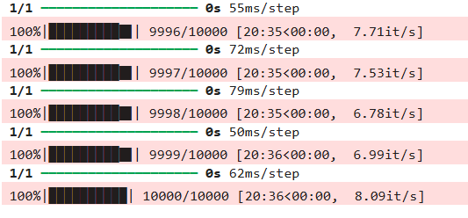

*Figure 4.1.2.4.* Training Result

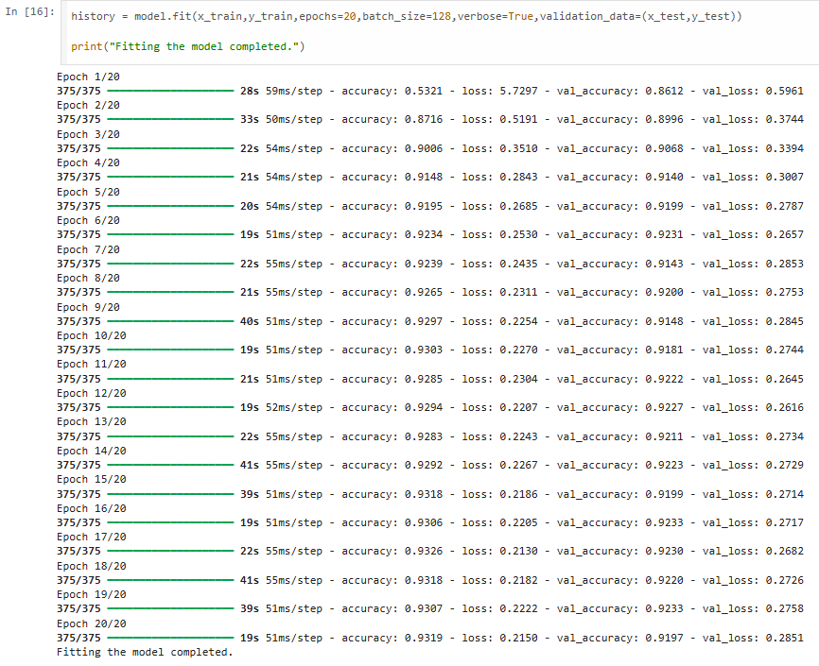

*Figure 4.1.2.5.* Custom VGG-16 Model Fitting

Figure 4.1.2.6 illustrates example classification results using the VGG16 model in a transfer learning context. Each image represents a handwritten digit along with its predicted label, confidence score (as a percentage), and the true label shown in parentheses. The green vertical bar indicates correct classifications, while red bars denote misclassifications. Most predictions are highly confident, with many achieving 100% certainty. The overall accuracy appears visually consistent with strong performance across various digits, such as “Seven 100% (Seven)” and “Zero 100% (Zero)”. A few cases, such as “Nine 53% (Nine)” or “Two 95% (Two)”, show reduced confidence, which is typical for ambiguous or poorly written digits. These results highlight the effectiveness of transfer learning using VGG16 in digit recognition tasks, demonstrating that even a model pre-trained on natural images can successfully generalize to digit classification with minimal training modifications.

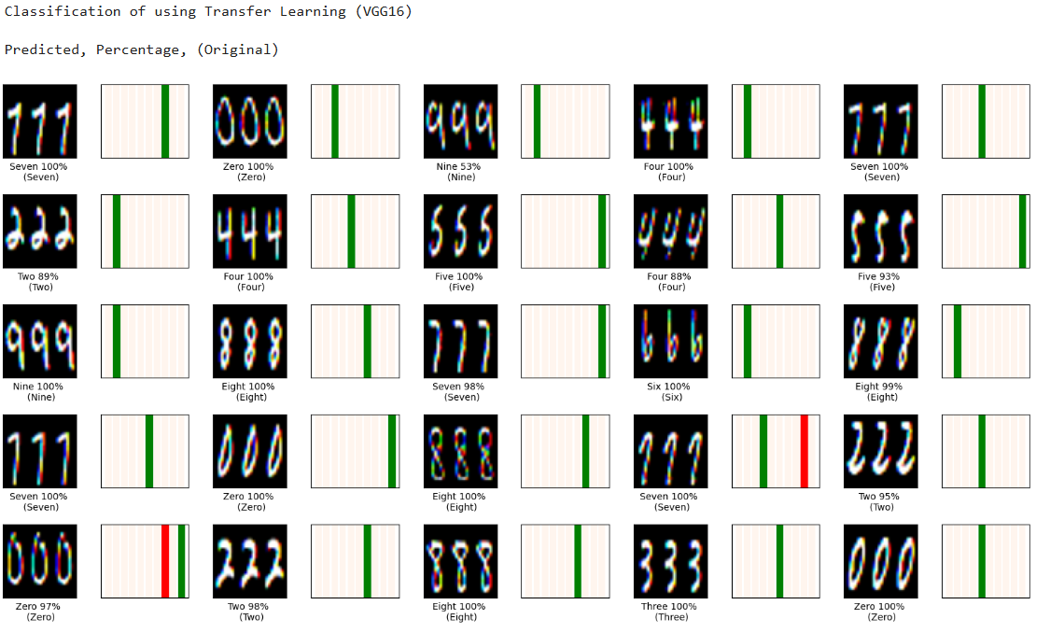

*Figure 4.1.2.4.* Example Classification

The model's training and validation performance are illustrated in Figures 4.1.2.7 and 4.1.2.8. The accuracy graph in Figure 4.1.2.7 shows a steady increase in both training and validation accuracy across 20 epochs, with both curves stabilizing above 90%. This indicates that the model effectively learns to classify the input data while generalizing well to unseen samples. The minimal gap between the two curves suggests that overfitting is largely avoided. Figure 4.1.2.8 depicts the corresponding loss curves, which show a rapid decline during the initial epoch and gradual convergence thereafter. The training loss continues to decrease slightly, while the validation loss stabilizes early on. Together, these figures demonstrate that the model has achieved strong convergence with high generalization capability, validating the effectiveness of the chosen architecture and training configuration.

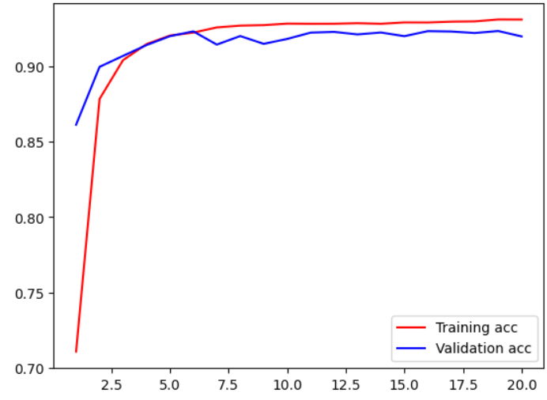

*Figure 4.1.2.7.* Training and Validation Accuracy

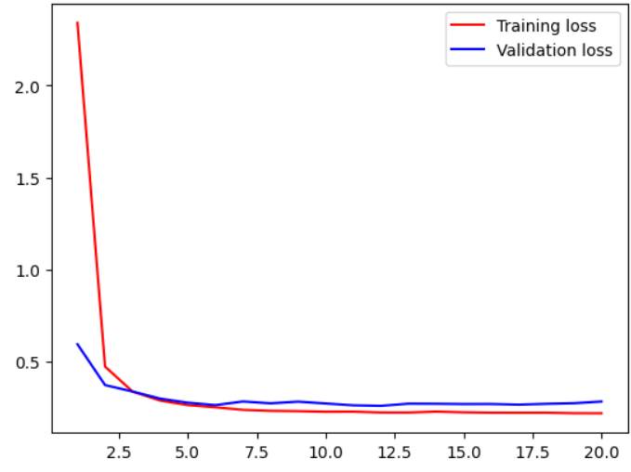

*Figure 4.1.2.8.* Training and Validation Loss

## Image Conversion

### HEX file

Figure 4.2.1.1 confirms the successful execution of the image conversion script, which transforms an MNIST digit image into a .hex file suitable for simulation. The terminal output shows that the Python script image_signed_convert_16bit.py was run without errors, and the converted data was saved to the specified directory. The minimum and maximum of the hex converted file ranged from -8192 to 8192. The output file contains the processed pixel values of the image are shown in Figure 4.2.1.2, encoded in a format compatible with the Verilog-based image RAM for the simulation. There are 784 values total representing the 28x28 image.



*Figure 4.2.1.1.* Success converting image to .dat

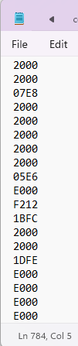

*Figure 4.2.1.2.* File .hex content

### MIF file

Figure 4.2.2.1 indicates the completed conversion script to MIF format, which is suitable for FPGA synthesis. The terminal shows that the Python script image_signed_mif_convert_16bit.py run successfully, and all the converted values were saved to the directory. The minimum and maximum of the mif converted file is similar to hex file, which are from -8192 to 8192. The content is shown in Figure 4.2.2.2, and it also has 784 values.



*Figure 4.2.2.1.* Success converting image to .mif

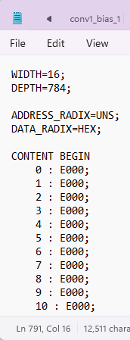

*Figure 4.2.2.2.* File .mif content

## Weights and Biases Conversion

### HEX file

Figure 4.3.1.1 displays the successful execution of the weights_biases_hex_generator_16bit.py script, which converts trained model parameters from .txt format into .hex files compatible with Verilog-based memory initialization. The terminal output confirms that separate HEX files were created for each layer’s weights and biases, including conv1_weight_14.hex, conv1_bias_14.hex, conv2_weight_14.hex, conv2_bias_14.hex, fc_weight_14.hex, and fc_bias_14.hex. The number of values written into each file is also shown, matching the expected size of each layer based on the trained CNN model. These HEX files are later loaded into simulation using $readmemh, allowing the hardware to perform inference using the exact weights obtained during training. This step is essential for ensuring consistency between the software and hardware implementations of the neural network. The content of the first convolutional weight is shown in Figure 4.3.1.2, and it also has 784 values.

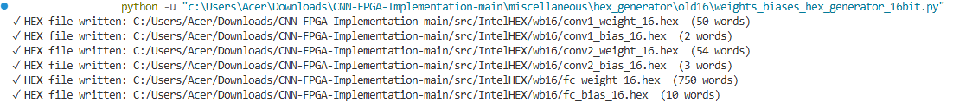

*Figure 4.3.1.1.* Success converting .txt file to .hex file

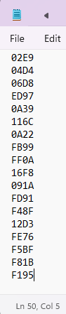

*Figure 4.3.1.2.* File .hex of the first convolution weight after conversion

### MIF file

Figure 4.3.2.1 indicates the completed conversion of weights and biases script to MIF format, which is compatible for FPGA synthesis. The terminal shows that the Python script image_signed_mif_convert_16bit.py run successfully, and all the converted values were saved to the directory. The minimum and maximum of the mif converted file is similar to hex file, which are from -8192 to 8192. The content is shown in Figure 4.3.2.2, and it also has 784 values.

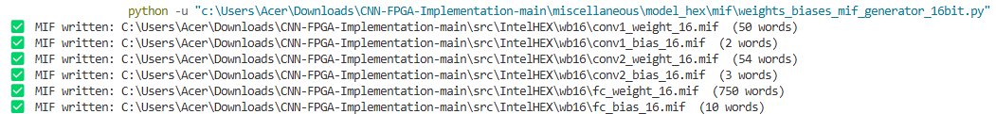

*Figure 4.3.2.1.* Success converting weights and biases to .mif

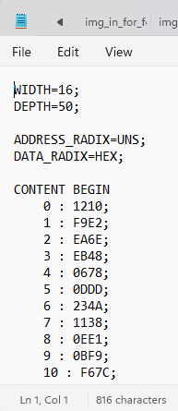

*Figure 4.3.2.2.* File .mif content

## CNN Model Layers

### First Convolutional Layer and ReLU

Figure 4.4.1.1 illustrates the simulation waveform of the convolutional layer and ReLU activation function module during the hardware-level implementation of the CNN model. This output was generated using ModelSim. The figure displays various control and data signals, including the clock (clk), reset (reset_n), start (start_conv1), data valid signal (data_valid), image and weight memory buses, as well as the computed feature map output. The simulation confirms that image, weight and bias data are correctly read from memory and processed to the array. The finish signal transitions high once the computation completes, indicating successful execution of the convolution operation.

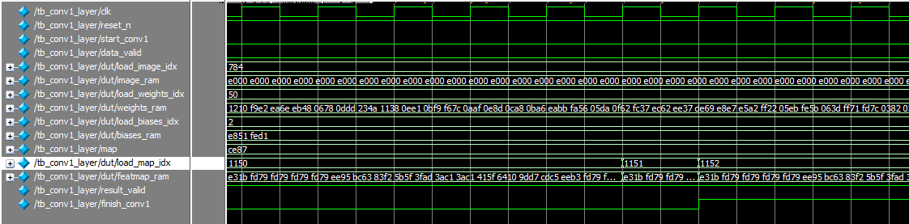

*Figure 4.4.1.1.* First Convolutional Layer Waveform

The memory initialization data for the convolutional layer simulation is shown in the three figures below. Figure 4.4.1.2 displays the contents of the image_ram, where pixel values from the input image have been stored in hexadecimal format. These values represent the fixed-point encoded grayscale intensity levels used for convolution. The structure confirms proper image loading, with non-zero values corresponding to the image pixel regions of the digit. Figure 4.4.1.3 shows the weights_ram, containing preloaded kernel weights for the convolutional filters. Each 16-bit value represents a fixed-point weight from the trained CNN model, formatted using Q2.13 notation. The organized layout confirms correct memory addressing for multi-channel convolution operations. Figure 4.4.1.4 presents the biases_ram, where the corresponding bias values for each output filter are stored. The presence of valid bias data, shown as e851 and fed1, confirms that the hardware is correctly incorporating bias during convolution. Together, these memory snapshots confirm the successful loading and formatting of input image data, filter weights, and biases, validating the initialization stage before convolution execution in FPGA simulation.

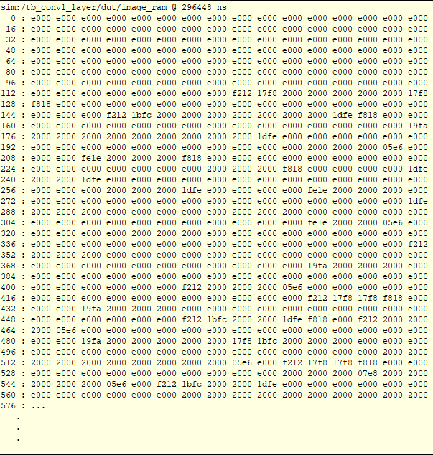

*Figure 4.4.1.2.* Image RAM of First Convolution Layer

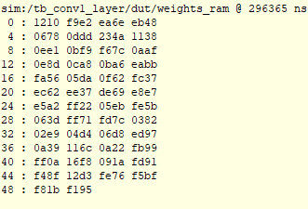

*Figure 4.4.1.3.* Weights RAM of First Convolution Layer



*Figure 4.4.1.4.* Biases RAM of First Convolution Layer

Figure 4.4.1.5 illustrates the contents of the feature map RAM corresponding to the first convolutional layer in the simulation environment. Captured at 296,435 ns, this output represents the raw activation data produced by the convolution operation applied to the input image. Each row shows a memory address offset followed by a sequence of hexadecimal values, which corresponds to two channels, each has 24x24 size value. These values reflect the result of applying filters to local regions of the input data, highlighting areas of high activation which typically correspond to features such as edges or textures. Repeating patterns like fd79 and higher-value activations suggest both different grayscale color level activations across different spatial regions. There is no negative value because of the ReLU activation function. The simulation output verifies that the convolution logic is functioning correctly and storing results as expected in the dedicated RAM module.

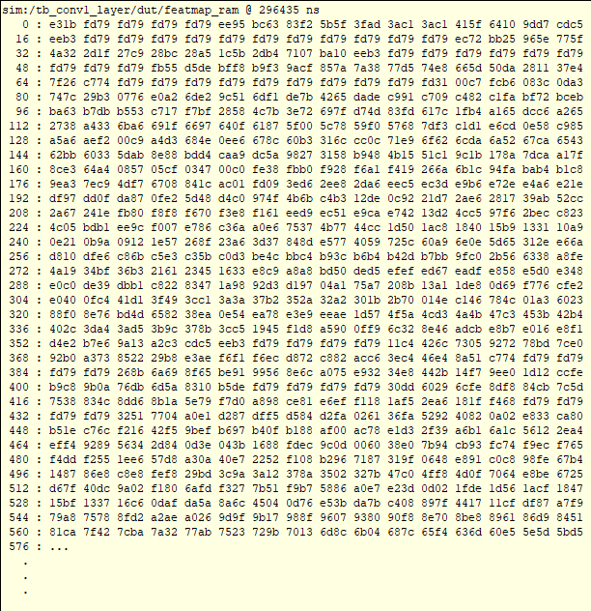

*Figure 4.4.1.5.* Feature Map RAM of First Convolution Layer

Figure 4.4.1.6 captures the SignalTap II Logic Analyzer during the *image-load* phase of the first convolution layer. In Figure 4.4.1.7, after asserting a hardware reset by lowering slide-switch SW17, the user raises SW16 to issue the start pulse; the controller then streams the 28 × 28-pixel MNIST frame (784 words, which equals 0x310 in hexadecimal) into on-chip memory. To aid debugging, the design drives the seven-segment displays so that HEX7-HEX4 present the current image-RAM address while HEX3-HEX0 present the 16-bit pixel value being written. In the photograph the address field reads “00A2” and the data field “F818”, confirming that the loader is progressing correctly through the dataset.

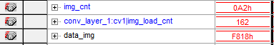

*Figure 4.4.1.6.* Load Image First Convolution Layer

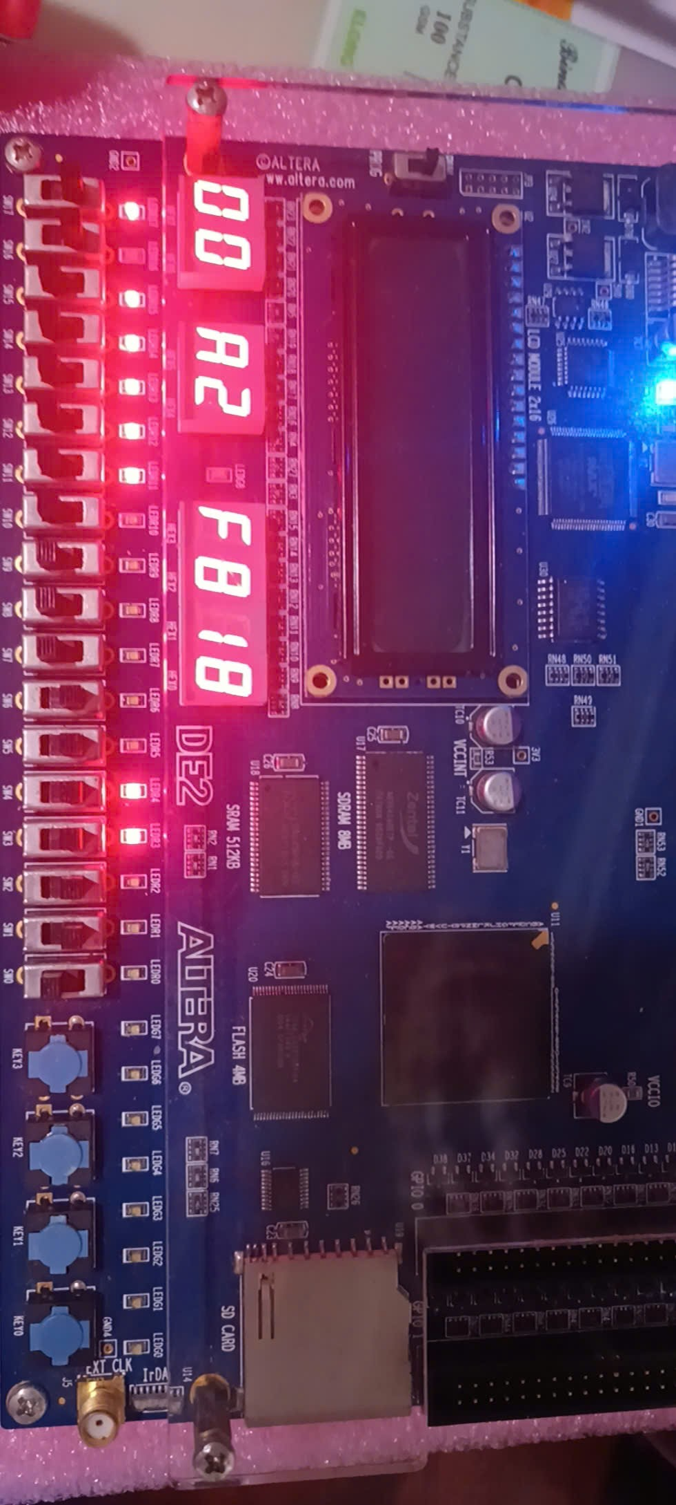

*Figure 4.4.1.7.* Load Image First Convolution Layer

Figure 4.4.1.8 illustrates the DE2 board while the first convolutional layer is running. After the entire 28 × 28 image has been loaded, the user raises switch SW1; this generates the start_conv1 pulse that moves the controller from the load state to the compute state. For every clock in which the MAC engine produces a new pixel, the design routes diagnostic signals to the front-panel indicators: HEX7–HEX4 present the current map address, HEX3–HEX0 present the 16-bit result, and LEDG[0] toggles with result_valid, giving a visible heartbeat. Because the layer has two feature-maps of 24 × 24 pixels, the address counter advances to 1152 decimal (0x480) before stopping. When that terminal count is reached, the core asserts finish_conv1; LEDG[3] lights steadily, confirming that the first convolution has completed successfully.

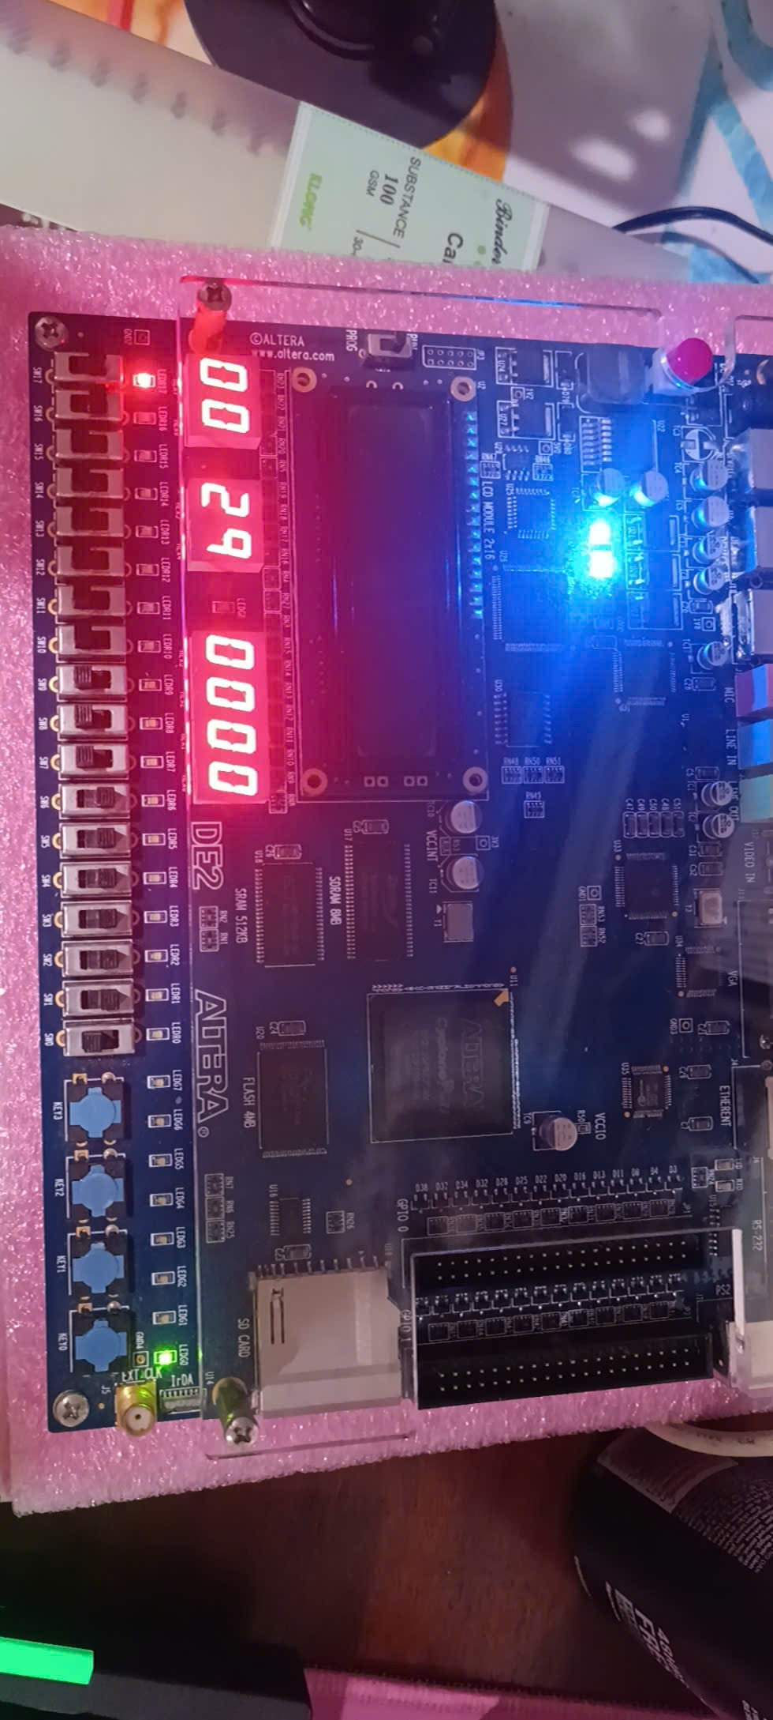

*Figure 4.4.1.8.* Map Output First Convolution Layer

### First Max Pooling Layer

Figure 4.4.2 displays the simulation waveform of the first MaxPool2x2ReLU module, highlighting the functional behavior of the max-pooling operation with integrated ReLU activation. The waveform shows key signals such as the clock (clk), reset (reset_n), start signal (start_max1), data valid signal (data_valid), input data (data_in), test data RAM and addresses, result valid signal (result_valid), finish signal (finish_max1) and final output (data_out). Initially, the start_max1 signal is asserted low, and upon activation, the input_data receives random test values. The max pooling operation proceeds, extracting the maximum values from local 2x2 regions, and save to the RAM. Finally, the finish_max1 signal is asserted to indicate completion. This waveform confirms the correct timing, control, and data flow through the max-pooling and ReLU logic in the hardware implementation.

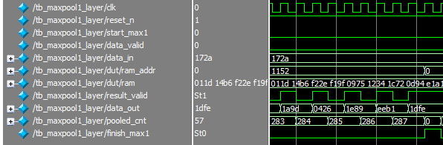

*Figure 4.4.2.* First MaxPool2x2ReLU Waveform

### Second Convolutional Layer and ReLU

The waveform shown in Figure 4.4.3.1 represents the simulation output of the second convolutional layer (conv2_layer) during model training on FPGA. This visualization includes key control signals such as the clock (clk), reset (reset_n), and start trigger (start_conv2), as well as memory interfaces for image, weight, and bias data. Once the start signal is asserted, image and kernel data are sequentially fetched from their respective memory arrays (image_ram, weights_ram, biases_ram), as shown in Figure 4.4.3.2, 4.4.3.3 and 4.4.3.4. The result of this operation is reflected in the map output and the featmap RAM at the bottom of the waveform, where a dense matrix of fixed-point values indicates the computed feature map. The transition of the finish signal to high marks the completion of the convolution process. This confirms that the second convolutional layer has functionally completed its forward pass, successfully consuming inputs and producing the corresponding output map. The result is essential for validating the sequential execution and correctness of deeper layers in the FPGA-accelerated CNN inference pipeline.

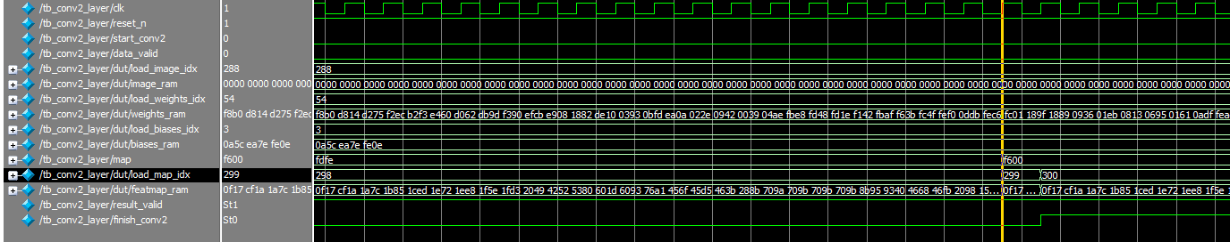

*Figure 4.4.3.1.* Second Convolutional Layer Waveform

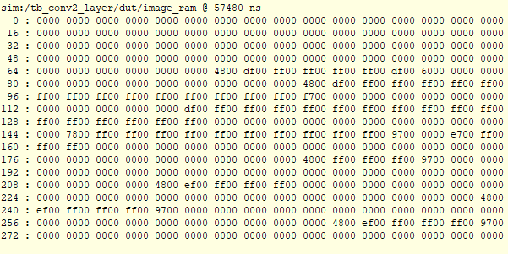

*Figure 4.4.3.2.* Image RAM of Second Convolution Layer

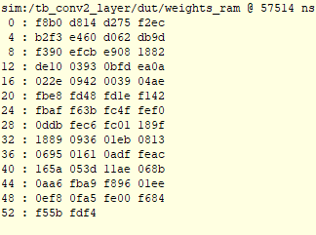

*Figure 4.4.3.3.* Weights RAM of Second Convolution Layer



*Figure 4.4.3.4.* Biases RAM of Second Convolution Layer

Figure 4.4.3.5 presents the contents of the feature map RAM generated by the second convolutional layer at a simulation timestamp of 57,534 ns. This output shows the memory structure storing the convolutional and ReLU activations in hexadecimal format, representing processed pixel values after the second convolution operation. Compared to the first layer, this feature map exhibits a wider distribution and higher variation in values, indicating more complex feature extraction due to increased filter depth and receptive field. The presence of zeroes suggests regions with low activation, possibly filtered out due to low feature significance. This feature map is a crucial intermediate result, feeding into deeper layers and capturing higher-level representations of the input data. The successful capture and organization of these values into RAM verify the correct implementation of the convolution module and memory handling in the hardware simulation.

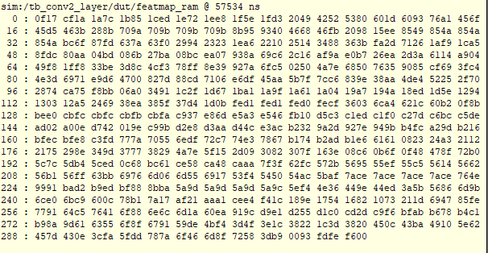

*Figure 4.4.3.5.* Feature Map RAM of Second Convolution Layer

### Second Max Pooling Layer

Figure 4.4.4.1displays the simulation waveform of the second MaxPooling layer with ReLU activation, confirming the successful execution of the MaxPool2x2 operation. The control signals include the clock (clk), reset (reset_n), and start trigger (start_max2). Initially, the start signal is asserted, which is expected before valid input is received. Upon activation of the pooling operation, the data_out signal transitions from undefined to valid fixed-point values, representing the downsampled feature map after the maximum operation is applied to 2×2 regions of the input. The assertion of the finish signal indicates the end of the pooling process. This simulation demonstrates that the MaxPooling layer not only performs spatial downsampling but also maintains the non-linearity introduced by ReLU, ensuring proper feature propagation through the CNN hardware pipeline.

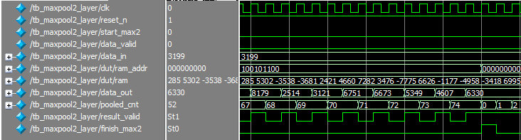

*Figure 4.4.4.1.* Second MaxPool2x2ReLU Layer Waveform

### Fully Connected Layer

Figure 4.4.5 illustrates the simulation waveform of the fully connected (FC) layer, capturing the timing and data flow during the classification phase of the neural network. The clock (clk) and control signals (reset_n, start_fc, data_valid) manage the operation's sequencing, ensuring synchronized processing. Input data is sourced from previous value of the second max pooling layer, while the FC computations are driven by weights_ram and biases_ram. The accum and shift_accum shows the intermediate computed values, reflecting the accumulation and bias addition performed during matrix multiplication. The final prediction output, shown in the predict_out value, is displayed as a hexadecimal result, representing the encoded class probabilities or logits. The assertion of the finish_fc signal indicates the end of the computation, verifying the successful implementation and functionality of the FC layer in hardware.

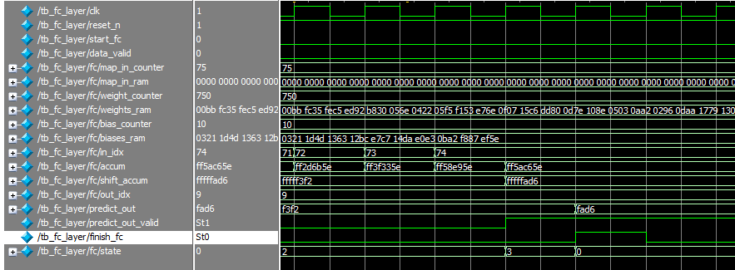

*Figure 4.4.5.* Fully Connected Layer Waveform

### ArgMax Layer

Figure 4.4.6 presents the waveform of the ArgMax layer, which is responsible for determining the predicted digit by identifying the index of the value with the maximum propability from the fully connected layer's output. The simulation begins with the start_argmax signal initiating the operation, while the clk signal drives the synchronous logic. The input data loads a vector of classification probabilities. As the operation progresses, the val_array holds the probability for each digit. The index_out signal eventually outputs the index of the maximum value holds by the max_val after comparison, which indicates the predicted class. The finish_argmax signal is asserted once the comparison is complete, confirming the successful execution of the ArgMax operation and enabling downstream modules to use the classification result.

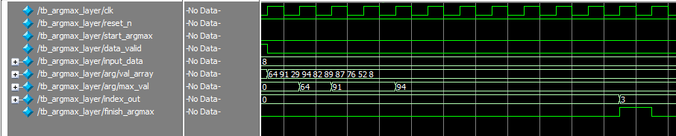

*Figure 4.4.4.* ArgMax Layer Waveform

### Top Module Layer

For each digit, three tests are executed between 16 bits and 32 bits to verify the validation of the design. Each decimal value in the val_array represents the probability of the digit prediction, the index at the highest value is the predicted digit output. Some test cases are not accurate, however, the difference between the probabilities is not significantly distinct. The 32-bit tests have a higher accuracy than the 16-bit tests due to more precision in calculation, in 32-bit tests, the fraction part of the value is 8-digit longer than the 16-bit tests. Sixty figures from 4.4.7.1 to 4.4.7.60 demonstrated digits recognition test, each digit has 3 different image input written by hand.

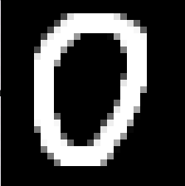

*Figure 4.4.7.1.* Raw Image Input – Number 0 First Test (16 bits)

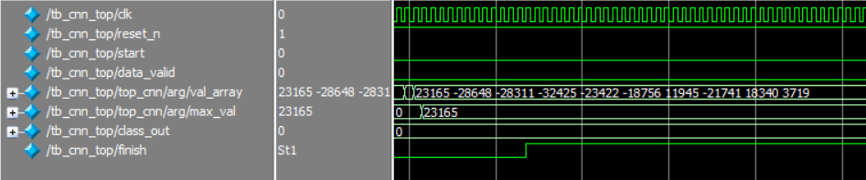

*Figure 4.4.7.2.* Top Module Layer Waveform – Number 0 First Test (16 bits)

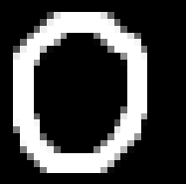

*Figure 4.4.7.3.* Raw Image Input – Number 0 Second Test (32 bits)

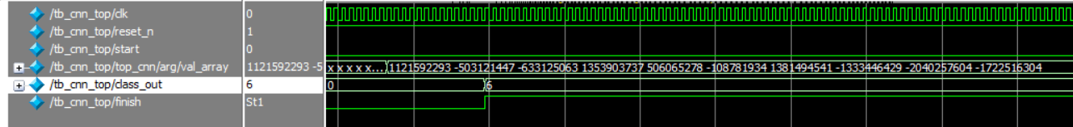

*Figure 4.4.7.4.* Top Module Layer Waveform – Number 0 Second Test (32 bits)

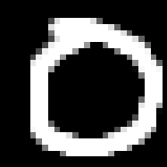

*Figure 4.4.7.5.* Raw Image Input – Number 0 Third Test (32 bits)

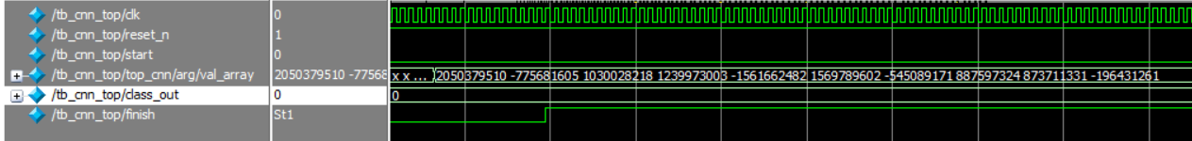

*Figure 4.4.7.4.* Top Module Layer Waveform – Number 0 Third Test (32 bits)



*Figure 4.4.7.7.* Raw Image Input – Number 1 First Test (16 bits)

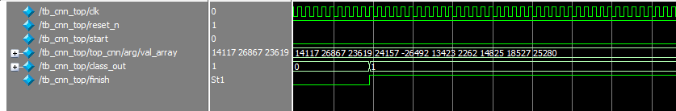

*Figure 4.4.7.8.* Top Module Layer Waveform – Number 1 First Test (16 bits)

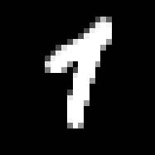

*Figure 4.4.7.9.* Raw Image Input – Number 1 Second Test (32 bits)

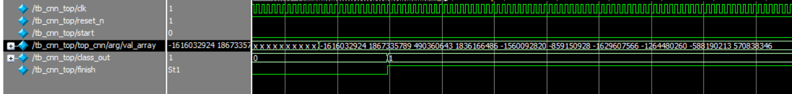

*Figure 4.4.7.10.* Top Module Layer Waveform – Number 1 Second Test (32 bits)

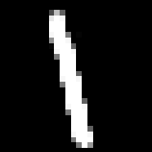

*Figure 4.4.7.11.* Raw Image Input – Number 1 Third Test (32 bits)

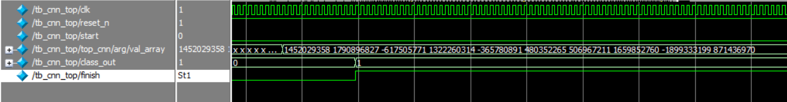

*Figure 4.4.7.12.* Top Module Layer Waveform – Number 1 Third Test (32 bits)



*Figure 4.4.7.13.* Raw Image Input – Number 2 First Test (16 bits)

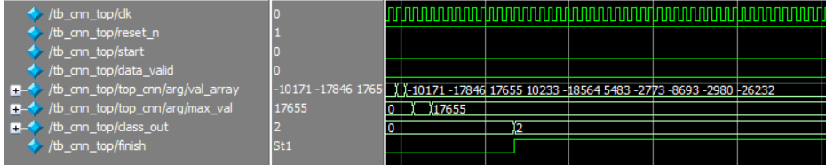

*Figure 4.4.7.14.* Top Module Layer Waveform – Number 2 First Test (16 bits)

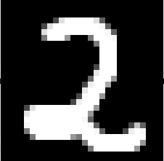

*Figure 4.4.7.15.* Raw Image Input – Number 2 Second Test (16 bits)

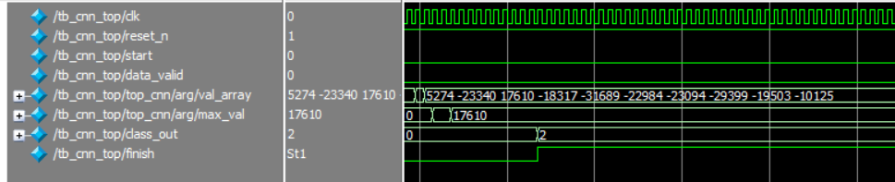

*Figure 4.4.7.14.* Top Module Layer Waveform – Number 2 Second Test (16 bits)

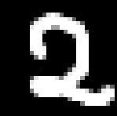

*Figure 4.4.7.17.* Raw Image Input – Number 2 Third Test (32 bits)

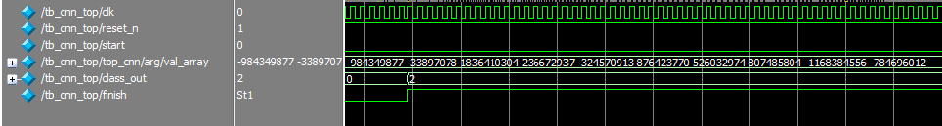

*Figure 4.4.7.18.* Top Module Layer Waveform – Number 2 Third Test (32 bits)

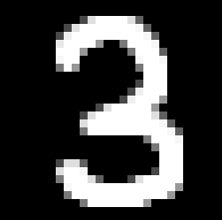

*Figure 4.4.7.19.* Raw Image Input – Number 3 First Test (16 bits)

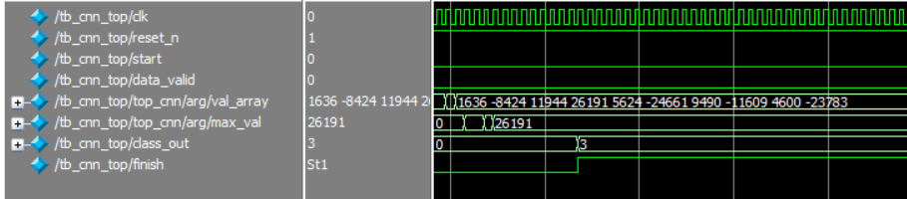

*Figure 4.4.7.20.* Top Module Layer Waveform – Number 3 First Test (16 bits)

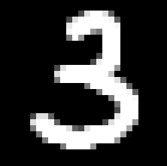

*Figure 4.4.7.21.* Raw Image Input – Number 3 Second Test (16 bits)

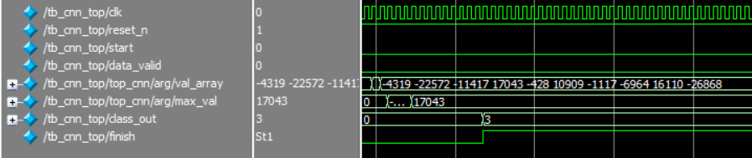

*Figure 4.4.7.22.* Top Module Layer Waveform – Number 3 Second Test (16 bits)

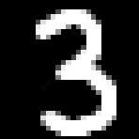

*Figure 4.4.7.23.* Raw Image Input – Number 3 Third Test (32 bits)

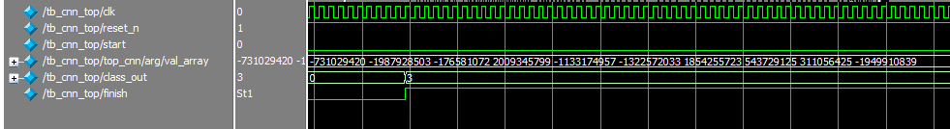

*Figure 4.4.7.24.* Top Module Layer Waveform – Number 3 Third Test (32 bits)

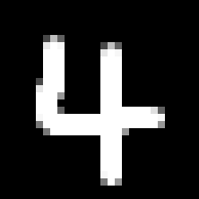

*Figure 4.4.7.25.* Raw Image Input – Number 4 First Test (16 bits)

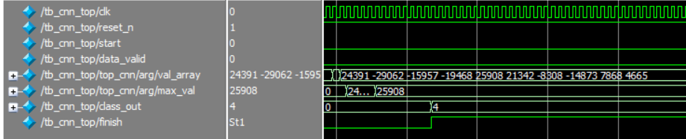

*Figure 4.4.7.24.* Top Module Layer Waveform – Number 4 First Test (16 bits)

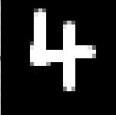

*Figure 4.4.7.27.* Raw Image Input – Number 4 Second Test (32 bits)

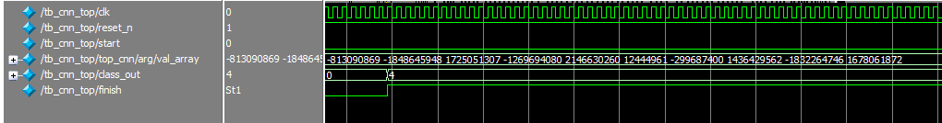

*Figure 4.4.7.28.* Top Module Layer Waveform – Number 4 Second Test (32 bits)

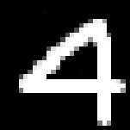

*Figure 4.4.7.29.* Raw Image Input – Number 4 Third Test (32 bits)

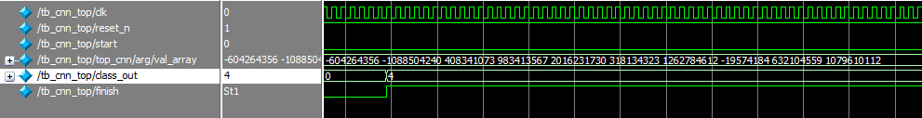

*Figure 4.4.7.30.* Top Module Layer Waveform – Number 4 Third Test (32 bits)

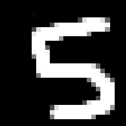

*Figure 4.4.7.31.* Raw Image Input – Number 5 First Test (16 bits)

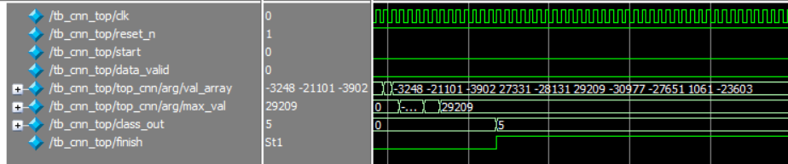

*Figure 4.4.7.32.* Top Module Layer Waveform – Number 5 First Test (16 bits)



*Figure 4.4.7.33.* Raw Image Input – Number 5 Second Test (32 bits)

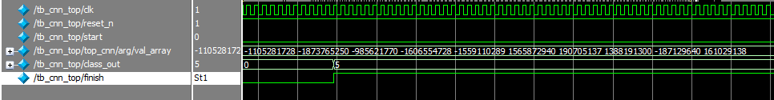

*Figure 4.4.7.34.* Top Module Layer Waveform – Number 5 Second Test (32 bits)



*Figure 4.4.7.35.* Raw Image Input – Number 5 Third Test (32 bits)

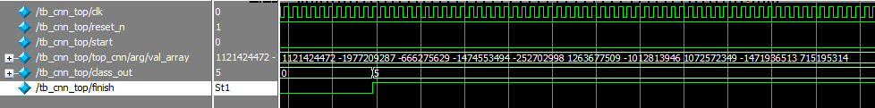

*Figure 4.4.7.34.* Top Module Layer Waveform – Number 5 Third Test (32 bits)

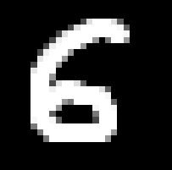

*Figure 4.4.7.37.* Raw Image Input – Number 6 First Test (16 bits)

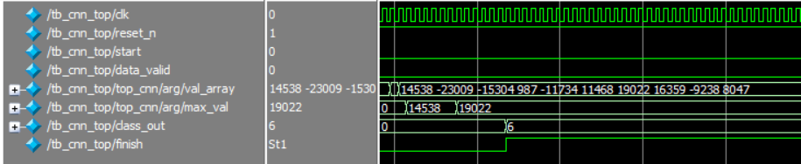

*Figure 4.4.7.38.* Top Module Layer Waveform – Number 6 First Test (16 bits)



*Figure 4.4.7.39.* Raw Image Input – Number 6 Second Test (16 bits)

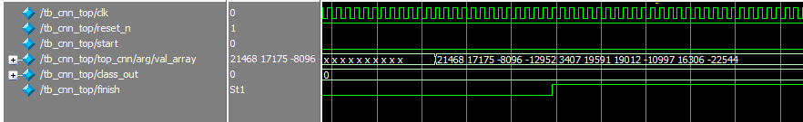

*Figure 4.4.7.40.* Top Module Layer Waveform – Number 6 Second Test (16 bits)

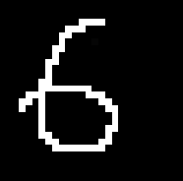

*Figure 4.4.7.41.* Top Module Layer Waveform – Number 6 Third Test (32 bits)

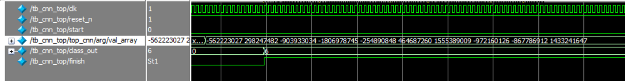

*Figure 4.4.7.42.* Top Module Layer Waveform – Number 6 Third Test (32 bits)

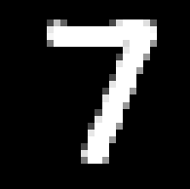

*Figure 4.4.7.43.* Raw Image Input – Number 7 First Test (16 bits)

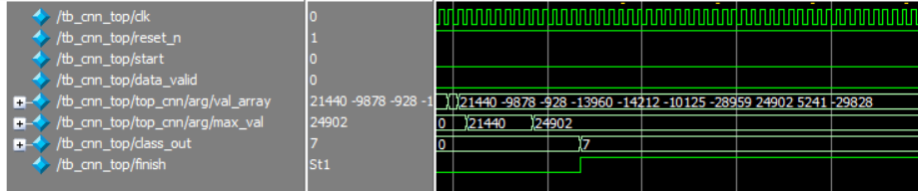

*Figure 4.4.7.44.* Top Module Layer Waveform – Number 7 First Test (16 bits)

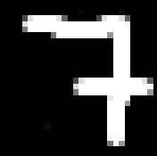

*Figure 4.4.7.45.* Raw Image Input – Number 7 Second Test (16 bits)

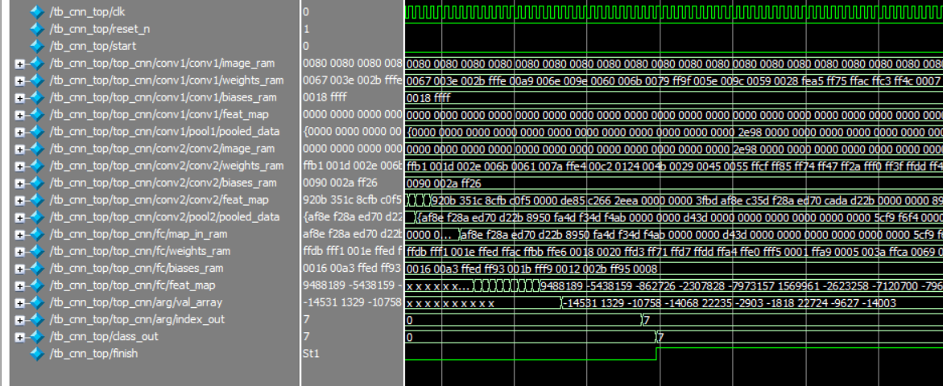

*Figure 4.4.7.44.* Top Module Layer Waveform – Number 7 Second Test (16 bits)



*Figure 4.4.7.47.* Raw Image Input – Number 7 Third Test (32 bits)

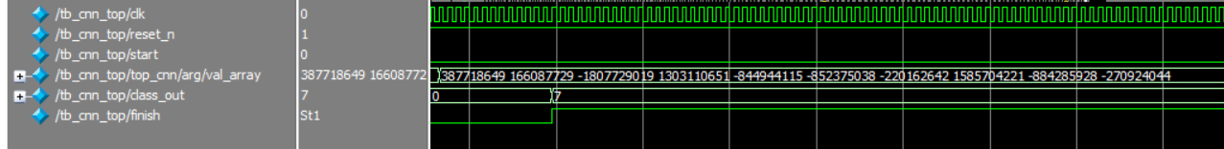

*Figure 4.4.7.48.* Top Module Layer Waveform – Number 7 Third Test (32 bits)

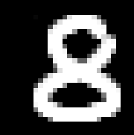

*Figure 4.4.7.49.* Raw Image Input – Number 8 First Test (16 bits)

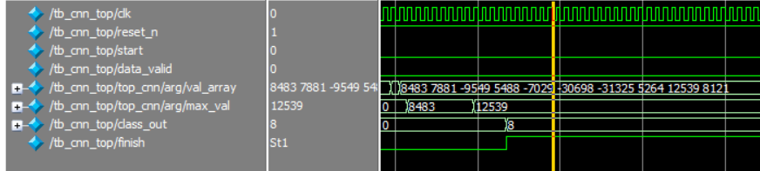

*Figure 4.4.7.50.* Top Module Layer Waveform – Number 8 First Test (16 bits)



*Figure 4.4.7.51.* Raw Image Input – Number 8 Second Test (16 bits)

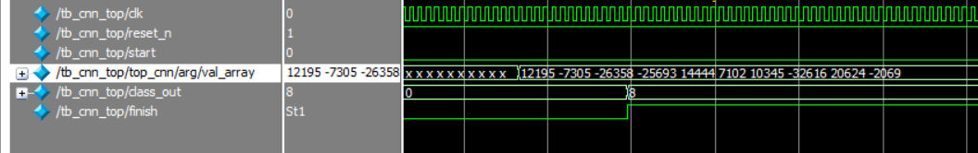

*Figure 4.4.7.52.* Top Module Layer Waveform – Number 8 Second Test (16 bits)



*Figure 4.4.7.53.* Raw Image Input – Number 8 Third Test (32 bits)

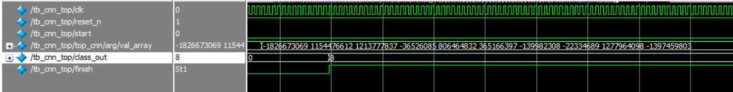

*Figure 4.4.7.54.* Top Module Layer Waveform – Number 8 Third Test (32 bits)



*Figure 4.4.7.55.* Raw Image Input – Number 9 First Test (16 bits)

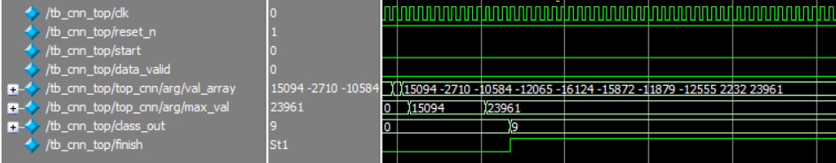

*Figure 4.4.7.54.* Top Module Layer Waveform – Number 9 First Test (16 bits)

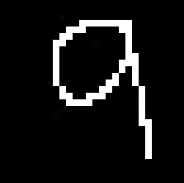

*Figure 4.4.7.57.* Raw Image Input – Number 9 Second Test (32 bits)

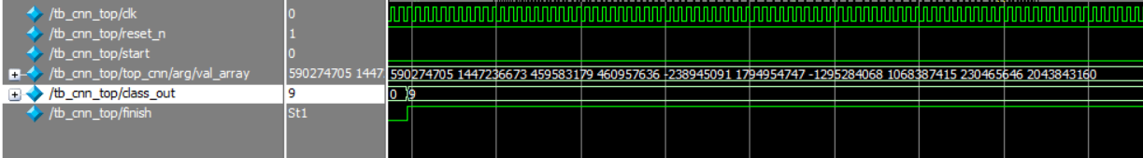

*Figure 4.4.7.58.* Top Module Layer Waveform – Number 9 Second Test (32 bits)

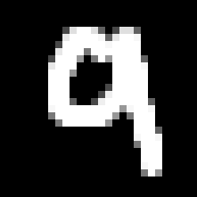

*Figure 4.4.7.59.* Raw Image Input – Number 9 Third Test (32 bits)

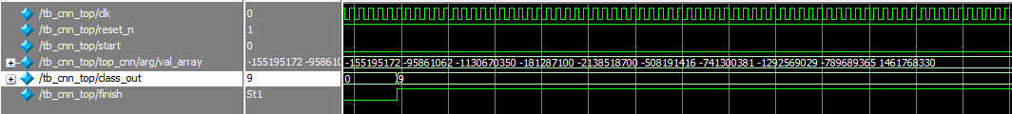

*Figure 4.4.7.60.* Top Module Layer Waveform – Number 9 Third Test (32 bits)

# CHAPTER V CONCLUSION AND FUTURE WORK

## Conclusion

In conclusion, the successful design and implementation of the handwritten digit recognition first convolutional layer on the Altera DE2 FPGA Board demonstrates the effectiveness of integrating machine learning with hardware acceleration and plays an important role in continuing to implement the system. By utilizing both a simple CNN and VGG16 for model evaluation, the project identified a reliable architecture capable of delivering high-accuracy predictions. The process of training, exporting, and deploying model weights and biases onto the FPGA using Verilog was executed effectively by observing the waveform. The outcome validates the feasibility of FPGA-based CNN deployment and highlights the potential for future developments in embedded machine learning and real-time digital signal processing applications.

## Future work

For future work, several enhancements can be made to improve the system's functionality, accuracy, and usability. First, the top-level Verilog module can be further optimized to improve clarity, modularity, and signal routing, making debugging and integration more efficient. Implementing a more structured and synchronized control flow using finite state machines (FSMs) will help ensure more predictable operation and easier waveform analysis during simulation. Expanding the input interface to accept live digit input through external devices such as a camera would enhance system interactivity. Furthermore, deploying more advanced quantization and compression techniques for weights and activations could reduce memory usage while maintaining accuracy, making the design even more resource efficient.

# REFERENCES

|  |  |  |
| --- | --- | --- |
| [1] |  | Chris Spear and Greg Tumbush*, System Verilog for Verification. A Guide to Learning the Testbench Language Features,* Third edition, New York, United State, 2014. |
| [2] |  | Nennie Farina Mahat, *Design of a 9-bit UART Module Based On Verilog HDL*, Kualar Lumpur, Malaysia, 2012 |
| [3] |  | Mason Leblanc, *Convolutional Neural Networks: A Comprehensive Guide to the Foundations, Architectures, and Applications of CNNs in Deep Learning and AI,* October 4, 2024. |
| [4] |  | Akshi Kumar, *Handwritten Digit Recognition Using Deep Learning,* September 11, 2017. |
| [5] |  | Thi Dieu Linh Nguyen, Elena Verdú, Anh Ngoc Le, Maria Ganzha, *Intelligent Systems and Networks,* August 19, 2023. |
|  |  |  |  | Akshi Kumar, *Handwritten Digit Recognition Using Deep Learning,* September 11, 2017. |